1

BRIDGTOWN PARISH COUNCIL
Minutes of the Parish Council Meeting.
Wednesday 10th November 2021.
At Bethel Methodist Church following guidelines during the Covid 19 Pandemic.

Present:
Cllrs. Val Jones (Chair), Kevin Whittaker (Vice-Chair), Matthew Freeman, Bob Eccleston, Peter Kruskonjic, Mandy Cook,

In Attendance:
Captain John Bailey

PUBLIC PARTICIPATION.

Guest speaker Captain John Bailey from 116 Provost Company 1 Regiment RMP gave a speech about the history and function his unit played within the armed forces. Captain Bailey mentioned the unit was established in Bridgtown in 2006 and they were happy to engage more with the Bridgtown Parish Council. He presented the Chair with a small Regimental shield. The Chair thanked him for his introduction to 116 Provost Company and looked forward to a continuing relationship between the Parish Council and the Unit.

THE PARISH COUNCIL MEETING WAS THEN OPENED.

Chair. Cllr. Val Jones welcomed newly elected Cllr. Mandy Cook to the Parish Council.

- Apologies received in writing prior to the meeting.

Apologies were received and accepted from Cllr. Paul Snape

RESOLVED: To accept the apologies of above Councillors.

- Declaration of Interests on agenda items and consideration of dispensations where appropriate.
None
- To Approve the Minutes of the Meeting held on 15th September 2021

The Chair requested two amendments:

Firstly that the name of the person who raised the issue of a no confidence vote in a councillor be removed from the minutes and be replaced by “a member of the public”.
Secondly the name of the Councillor named in the no confidence vote is replaced by “a Parish Councillor”.

Cllr Cook requested that the word “businesses” be replaced by “people” in reference to the no confidence vote. There was some debate as to whether the word “businesses” was used. In the absence of the member of public who made the statement it was agreed to replace this with the word “people”.

The three amendments to the minutes were proposed by Cllr Whittaker and seconded by Cllr Cook. The minutes were approved as a true record subject to the amendments above.

It was proposed by Cllr. Kevin Whittaker(Vice-Chairman), seconded by Cllr Freeman and agreed to approve the minutes.

RESOLVED: MINUTES WERE APPROVED.

- Matters Arising from the Minutes.(Not already on the Agenda)

RESOLVED: NOTED

- Chairman’s Report.

The Chairman gave her report (SEE APPENDIX 1)

- Consideration of reports received from the PCSO.

The PCSO reports had been submitted and was noted with the following comments.

- The PCSO’s reported that there had only been one incident of ASB recorded in Bridgtown over the last month.
- Cannock/Brigtown is still waiting for the PSPO to granted and implemented by CCDC, currently it looks like this will take place in January 2022.
- The PCSO gave out crime reduction/awareness leaflets to the Parish Councillors and advised about the Digital Platform for local crime reporting.
- The issue of inconsiderate parking around the school and in residential areas. The PCSO advised Councillors to report issues for repeat offenders. New Parish Clerk to report to “Clear Streets”
- Cllr Eccleston mentioned that Bridgtown lacked adequate provision as a consequence of local businesses utilising car parking bays that were designated to residents and shoppers.
- The issue of community safety during the Asylum Seekers stay at the Holiday Inn was raised by a member of the public. The PCSO stated they would have no part to play during this time. Chair to contact the Police to gain assurance on the role of the Police.
RESOLVED: NOTED.

- Recreational Areas.

  - The Leighton Memorial Garden.
Cllr. Bob Eccleston submitted a risk assessment to the Chair for the planting of the Christmas Tree and the attachments of the lights.

  - War Memorial.
No comments

  - Memorial Park & Gardens in Union Street.
The Chair commented that plans were in place to paint the play equipment in the park on 20th November 2021
to weather permitting.

7.4.Update regarding CCTV in the park.
The Chair commented that the Parish are still waiting for a decision to be made on the CCTV.

7.5 Update on the current position with vandalism at the park & gardens.
The Chair commented that there had been no further reports of incidents since the last meeting and Police were continuing to monitor the Park. See Chair’s report.

7.6 Bridgtown Friends of Bridgtown Park.
No update available
RESOLVED: Noted

RESOLVED: It was agreed the meeting would be adjourned to receive local community group reports.
None present

- Planning:

All planning issues have been circulated to Councillors for comment. No comments for note have been received within the deadline.

8.1 Applications for Consideration.
Cllrs.Mandy Cook & Bob Eccleston raised concerns about the application made to purchase the car park in Broad Street, with the intension of building houses on the site. Cllr. Peter Kruskonjic reported that he was in the process of writing to CCDC objecting to the sale of the land on the grounds of its intended usage, building further houses, and the issues of overcrowded parking in the area. Cllr. Mandy Cook was advised to also contact the other two District Councillors for Cannock South, Cllr. Krajaulis and Cllr. Witton.

  - Applications Approved/Rejected by District Council.
None received

RESOLVED: NOTED

- Correspondence.
  - Incoming - None
9.2Outgoing - None

RESOLVED: ALL RELEVANT POST HAD BEEN CIRCULATED AND NOTED.

- Accounts.
10.1 Payments for Approval
Date | Payee | Cheque Nr. | Amount VAT | Approved
10.11.21 | Brian’s Garden Hobby Crafts(Benches for School |  | 400.00 | approved
10.11.21 | British Heart Foundation(Defibrillator for the Bethel Chapel) |  | 1759.99 | approved
10.11.21 | Hollybush Nursery (Soil for planters) |  | 168.00 | approved
10.11.21 | Bethel Methodist Church(Hall hire) |  | 20.00 - | approved
10.11.21 | Jan Burns (Donation Bethel Church towards Christmas presents for children) |  | 150.00 | approved

RESOLVED: Authorisation of the accounts presented for payment totalling £2497.99 was agreed.

  - Consideration of the Current financial situation of the Council.

Due to the absence of a Parish Clerk the budget statement was not approved and it was agreed to defer this until the January meeting at which point there will be a Parish Clerk in attendance as the financial officer for the Parish
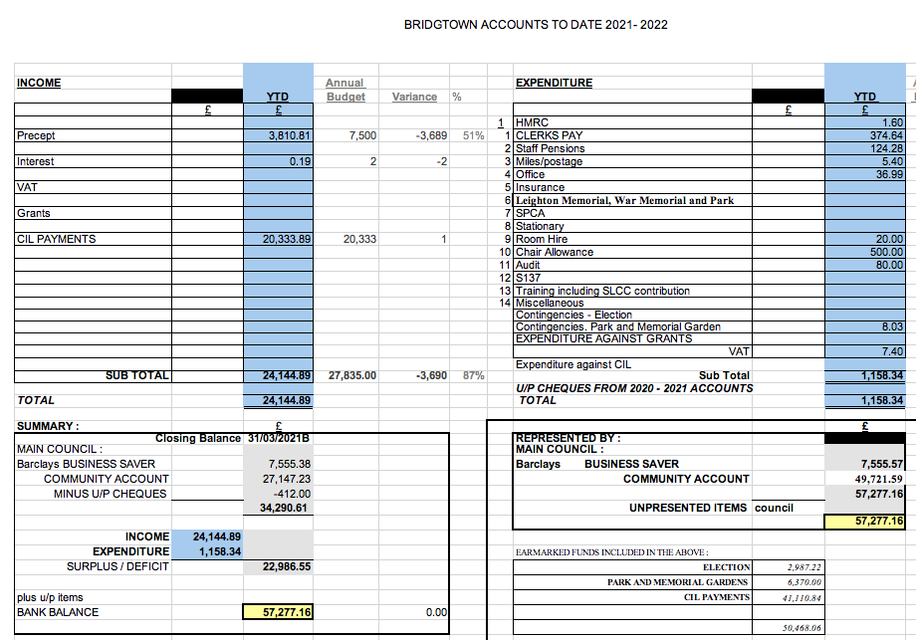

RESOLVED: TO DEFER APPROVAL OF THE ACCOUNTS

  - Consideration of infrastructure projects update
It was noted that there was currently £41,110.84 in the CIL Grant fund. The Parish Council had five years to spend the grant or it would have to be returned to the District Council for them to allocate on projects in the Cannock District. It was noted that £15,000 had being earmarked for Park and Garden improvements, including installation of CCTV and New Litter Bins. This would leave a balance of £26,110.84 to be spent by 2025/26.

  - Consideration of any grant funding application opportunities.
It was noted that grant schemes that Parish Councils were able to apply for were limited. Councillors had been asked to advise the Clerk of any schemes that were applicable to Parish Councils.

  - Consideration of any Grant applications Received.
The Chair reported that Jan Burns had requested help with funding Christmas gifts for the Children. Chair has completed an application form on behalf of Jan Burns for the sum of £150. Members of the Parish Council voted to approve this grant.

RESOLVED: Grant application for Jan Burns, Bethel Church approved.

  - Consideration of budget requirements for 2022-23 Precept.
Cllr’s Cook and Eccleston raised queries about the budget for the financial year 22/23. It was agreed that all accounts/budget related discussions and matters relating to this would be deferred until the next Parish meeting when the new Parish Clerk, as the financial officer for the Parish Council would be in post.

12.0 Highways Issues.
12.1 No reports from County Council regarding any Highways issues
  - Consideration of CIL proposals suspended until appointment of new Parish Clerk

- Data Protection
13.1 No comments

14.0 Confidential Items – exclusion of the press and public when applicable. Consideration of applications for Clerks Vacancy
14.1 Announcement of appointment of new Parish Clerk was covered in the Chairman’s report. A vote was taken to appoint Chris Gracey as the new Parish Clerk to be reviewed in May 2022.

15.0 Items for Information or Future Agendas.

15.1 Cllr. Bob Eccleston raised the issue regarding the emptying of the waste bins on Lakeside Boulevard. The developer is still under obligation to empty the bins on a scheduled basis until the site is adopted by CCDC in April 2022. The Chair will contact the developer again and request the bins are emptied on a regular basis.

15.2 Cllr. Bob Ecclestone queried the Queens Canopy Tree to commemorate the Queens Platinum Jubilee, 70 years of service. A commemorative plaque is issued to the Parish Council if they plant a tree in commemoration of the event. Planting season is between October and March and the next available session would be 2022.I t was agreed that the Parish Clerk would investigate this further as permission may be needed from the District Council and report back at the January 2022 meeting.

15.3 Cllr. Kevin Whittaker(Vice-chairman) volunteered to organise next year’s Remembrance Parade Marshalling following complaints he’d received about this year’s event.

16.Date of Next Meeting.
It was agreed that the next meeting would be Wednesday 12th January 2022, the Chair thanked everyone for their attendance and the meeting closed at 8.35pm.

RESOLVED: NEXT MEETING: 12th January 2022

APPENDIX 1

Bridgtown Parish Council
Chairman’s report
10th November 2021

- The Chair reported that the 116 Provost Company Royal Military Police(RMP) following an invitation by the Chair during a visit to RMP earlier this year with other Parish Councillors. The purpose of the visit was to make contact with RMP to foster a relationship with Bridgtown. One of the senior officers will be attending the Parish meeting on the 10th November to give a short briefing on the Unit. Army Cadets had also attended the Remembrance Parade in Bridgetown for the first time along with the Association of the Royal Engineers. The Chair thanked Captain Bailey and Amanda Milling MP who also attended along with other dignitaries.

- The Chair thanked Derek Middleton from the Historic Society for the fascinating presentation he gave on Walkmill Lane which took place on the 9th November. They were also thanked for their work in acquiring the new commemorative notice board that was due to be unveiled by the Parish Chair on Vine Lane on Saturday 13th November.
- Cllr Ecclestone volunteered to approach local businesses to contribute towards the funding for another defibrillator.
- Prince of Wales Trust: The park was considered for a project along with other nominations, after the Chair organised a visit to Bridgtown Park on the 8th October with Prince’s Trust local co-ordinator. The projects are selected from nominations by a panel of young people. Bridgtown Park was not selected on this occasion although came a close second choice. However young people expressed a desired to spend a day on garden work in the Park. This is to be arranged at their next panel meeting.
- Community Safety Hub: Following on from the referral made in early September by the Chair of Bridgtown Park to the Hub in respect of the problem of vandalism in there have been additional police patrols to the Park specifically in the evening. Advice has been given by a crime prevention officer on how to reduce the risk of vandalism. No recent incidences have been reported. The issue of CCTV is still awaiting a formal decision by the district council who have ownership of the land.
- Parish Clerk Vacancy: The Parish Council has advertised for a replacement following the resignation of the long standing clerk. There is a concern due to the nation shortage of Parish Clerks that the Parish Council will struggle to fill the position. The Parish Clerk is a critical role as the officer is responsible for the administration of the council and legally for the financial accounts. It would not be possible to function for any length of time without a qualified clerk. Additional adverts were sent out and other local clerks were approached consider Bridgtown in an addition to their current Parish.
- Automated External Defibrillator (AED): Some of the component parts of the AED which was proposed by Jan Burns, Bethel Church and funded by the Parish Council have started to arrive. The delay is due to the parts coming from aboard. As soon as it is complete free training by a accredited First Responder Group will be offered to the public delivered at Bethel Church. Further information will be made available when the AED is ready to operate. Consideration will be given by the Parish Council to funding a second device to provide good coverage across Bridgtown.

