1

BRIDGTOWN PARISH COUNCIL
Minutes of the Parish Council Meeting.
Wednesday 21st July 2021.
At Bethel Methodist Church following guidelines during the Covid 19 Pandemic.

Present:
Cllrs. Val Jones (Chair), Kevin Whittaker (Vice-Chair), Matthew Freeman, Bob Eccleston, Peter Kruskonjic.

In Attendance:
Leigh Jarratt. Friends of Bridgtown Park Community Group.
Janine Arm. Clerk to the Council.
Ray Smythe. Assisting the Clerk.
David Williams – Bridgtown History Society
John Stanley – Secretary Royal Engineers Association Cannock Branch
Sue Heath.
Charlotte Plant.
Cllr. Doug Smith, Chairman of Cannock Chase District Council.
Cllr. Luis Arduino.
Nikki Brown.
Martin Brown.
Chris Maddox.

PUBLIC PARTICIPATION.

John Stanley of the Royal Engineers Association addressed the meeting outlining the past liaison with the Parish Council regarding Remembrance Sunday. Bridgtown had traditionally held their service one week prior to the national allocated day. For 2021 the national recognised day for Remembrance Sunday was 14th November and Bridgtown intended having theirs as always, the week prior on 7th November. It had however come to the notice that this year the Cannock committee of the Royal British Legion had provisionally sent out invitations, not for the recognised Remembrance Sunday date, but for the 7th November.

The Parish Council confirmed that they fully supported the Royal Engineers proposed date of 7th November and would be in attendance. Cllr. Val Jones agreed to contact the Cannock Supporters of the Royal British Legion and remind them that Bridgtown traditionally had this date. Mr Stanley reported he would make arrangements for road closures and send out invitations to guests.

Cllr. Val Jones advised that 116 Royal Military Police would like to attend the Bridgtown Service.

Mr Stanley was thanked for his report.

David Williams of Bridgtown History Society gave a brief outline of the history of the society and that it was welcoming new members at an introductory cost of £5 per household. It was intended to produce a leaflet for public circulation advising of the work of the Bridgtown History Society.

The Society was currently developing a book about the history of Bridgtown and hoped to put in local libraries. Heritage boards had already been installed around the area, some of which had been donated. The next board would be installed on Walkmill Lane in September 2021.When all 12 of the intended Heritage boards were installed it would be promoted as A Heritage Walk between all the boards.

Following the funding by the Parish Council for a heritage ‘Blue Plaque’ for the building in which Doris Jones (known as Ma Pardoe, a local legend), was born, the opening ceremony would be held on Saturday 21st August 2021. A brief introduction by the family of Ma Pardoe would be held at the Bethel at 10am, followed by unveiling the plaque at 11am, followed by refreshments afterwards. Everyone was welcome to attend.
It was also noted that they were currently hoping to have a Heritage Centre in the Village, pending planning permission.

Mr Williams was thanked for his report.

No further issues were raised by members of the public present prior to the meeting.

THE PARISH COUNCIL MEETING WAS THEN OPENED.

- Apologies received in writing prior to the meeting.

Apologies were received and accepted from Cllrs. Maureen Freeman and Paul Snape.

RESOLVED: To accept the apologies of above Councillors.

- Declaration of Interests on agenda items and consideration o/f dispensations where appropriate.

No declarations of interest were made.

- To Approve the Minutes of the Meeting held on 26th May 2021.

It was proposed by Cllr Whittaker, seconded by Cllr Freeman and agreed to approve the minutes.

RESOLVED: MINUTES WERE APPROVED.

- Matters Arising from the Minutes.

Not already covered on the Agenda

Although the National Express bus service had confirmed there was no plan to reinstate the X1 through Bridgtown, Chaserider had confirmed a new timetable to include Bridgtown.

The Annual Audit been completed, published and sent to the Auditors.

RESOLVED: NOTED

No further matters arose not already covered on the agenda.

- Chairman’s Report.

The Chairman gave her report (SEE APPENDIX 1)

- Consideration of reports received from the PCSO.

The PCSO reports had been submitted and was noted with the following comments.

A spate of car thefts had been noted in the general area, primarily Ford Fiestas and Ford EcoSports. It was noted the Clerk had posted on Facebook and the webpage for residents to be vigilant.

PCSO Megan McAndrew and PCSO Luke Peckett had been visiting Bridgtown Park and Gardens, to get to know the local children

RESOLVED: NOTED.

- Recreational Areas.

  - The Leighton Memorial Garden.

No issues arose.

  - War Memorial.

It was noted that John Stanley from the Cannock branch of the Royal Engineers Association had addressed the Council regarding Remembrance Day for the 7th November 2021.

  - Memorial Park & Gardens in Union Street.

It was noted that the walls around the planting beds had been repaired.

It had been confirmed that the knotweed issue on the park had been reported to and was being dealt with by the District Council and they have confirmand they have visited both adjoining premises where the knotweed is persistent.

The businesses adjoining the park had accepted a proposed treatment plan and it was hoped to install a secure 'Euro Bin' on one of the sites, that will be locked to store cut off knotweed stems to rot away safely. Only two very small areas were identified at the back on the park and both near the border or on the border. It was confirmed that both areas have been treated already so will die away and the area will be safe from contamination spread. The Council had been advised that the area would be treated a further three times this year.

It was confirmed by the District Council that in this case there was no need to cordon off the area. The Parish Council was advised knotweed is a difficult problem to eradicate and will be an ongoing problem and whilst it can be seen it does not mean it was not being dealt with. Cllr. Eccleston expressed his concerns on the management plan of the District Council. Councillors noted his concerns but agreed that they had confidence that the treatment plan in place was appropriate. The situation would however be monitored.

RESOLVED: It was agreed that the Parish Council trusted the District Council to continue have an appropriate management plan in place to eradicate the Japanese Knotweed. Cllr. Eccleston objection was noted.

The problem would however be monitored by the Parish Council.

Adjournment of the meeting to receive the reports of ‘Friends of Bridgtown Park’.

RESOLVED: It was agreed the meeting would be adjourned to receive local community group reports.

- Consideration of reports From Leigh Jarratt on issues arising on Friends of Bridgtown Park.

Leigh Jarratt reported that the Friends of Bridgtown Park had made the CIL grant application for possible CCTV because of reported drug use, vandalism and general anti-social behaviour in the park and the concerns of residents about safety. Although the plans for CCTV were in the very early enquiry stages, it was hoped if installed it would give residents more confidence to use the park and gardens.

New litter bins had been installed as the old bins were in a bad state and needed replacing.

Cannock Chase District Council had repaired the vandalised walls but still had more work as bricks were still missing and needed replacing.

The benches had been repaired and it was hoped to paint them and the play equipment in the near future. All materials for painting were being donated. Chris Maddox also offered his help with the painting. He also would offer his help with plans for the local children to refresh the mural.

  - Update regarding planting at the park from Sue Heath.

Sue Heath advised the Council that although previously she had planted the three beds by the play area with summer flowers, they had been trampled down or dug up. She proposed that prior to completing all the new planting in the park, she would plant only one or two beds away from the pay area. As the Council had agreed a budget of £1,000 for the planting in the park and gardens, she suggested that more established robust plants and bushes were planted. The Council agreed it was a good idea.

Charlotte Plant asked if any consideration would be given to having a children’s allotment in one of the planters. Whilst it was thought this was a good idea, there were concerns that they would be vandalised. It was noted that Bridgtown Primary School had been growing plants for the gardens but Covid had prevented them from completing this initiative.

It was noted that Leigh Jarratt had approached a local plant supplier who was willing for the Council to set up an account.

  - Update on Repairs and Maintenance at the Park.

No further issues arose not already covered on the Agenda. Leigh Jarratt and Sue Heath were both thanked for their reports and for all the hard work they put in for the community.

RESOLVED: TO RECONVENE THE MEETING.

- Planning:

All planning issues have been circulated to Councillors for comment. No comments for note have been received within the deadline.

  - Applications for Consideration.
  - Applications Approved/Rejected by District Council.

RESOLVED: NOTED

- Correspondence.

  - Incoming.
  - Outgoing.

RESOLVED: ALL RELEVANT POST HAD BEEN CIRCULATED AND NOTED.

- Consideration of adopting grant application forms for applications to the Council.

It was proposed, seconded and agreed to adopt the proposed grant forms so that anyone wishing to apply to the Council for a grant could provide the correct information required for the Council to make a decision.

RESOLVED. TO ADOPT THE GRANT FORM

- Accounts.
  - Accounts for Consideration.
BRIDGTOWN PARISH COUNCIL ACCOUNTS FOR AUTHORISATION
Feb/March | HMRC - Tax and NI contributions £1.60 due - Clerk paid via bank xfr. and reclaimed) | £0.00
Feb/March | Janine Arm - Clerk pay two months (188.02 per month) | £376.04
February | Staffordshire Pension Fund 'SCC Superannuation fund | £62.14
March | Staffordshire Pension Fund 'SCC Superannuation fund | £62.14
Feb/March | Janine Arm - Clerk Expenses - postage/mileage + anti Virus £29.99 + HMRC £1.60 | £36.99
 | Bethel Methodist Church Hall Hire - no meeting in Hall | £20.00
 | Cannock Chase Council - supply and install standard litter bins | £1,281.00
 | TOTAL Expenditure | £1,838.31

RESOLVED: Authorisation of the accounts presented for payment totalling £1838.31 was agreed.
The Clerk was thanked for her work on the accounts.

  - Consideration of the Current financial situation of the Council.

It was agreed that the accounts presented as below, represented an accurate summary of the Council’s accounts as of the last bank statement received.
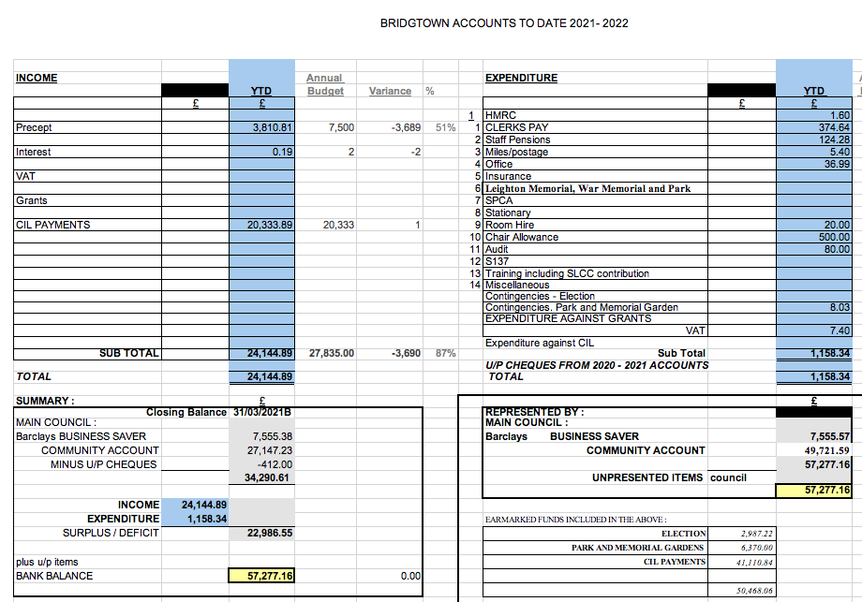

RESOLVED: TO APPROVE THE ACCOUNTS

  - Consideration of infrastructure projects update
It was noted that there was currently £41,110.84 in the CIL Grant fund. The Parish Council had five years to spend the grant or it would have to be returned to the District Council for them to allocate on projects in the Cannock District. It was noted that £15,000 had being earmarked for Park and Garden improvements, including installation of CCTV and New Litter Bins. This would leave a balance of £26,110.84 to be spent by 2025/26.

  - Consideration of any grant funding application opportunities.
It was noted that grant schemes that Parish Councils were able to apply for were limited. Councillors had been asked to advise the Clerk of any schemes that were applicable to Parish Councils.

  - Consideration of any Grant applications Received.
It was noted that Bethel Church had requested a grant to purchase an AED (Automated External Defibrillator). The cost including VAT would be up to £1,750. As the AED would be fitted to an outside wall and connected to an electricity supply. The Church advised they would cover the approx. £15 per annum cost of running the power. The Council agreed this was an excellent idea and would earmark up to £1,750 for the purchase of an AED for installation at Bethel Methodist Church.

RESOLVED. TO PURCHASE AN AED TO BE INSTALLED OUTSIDE BETHEL METHODIST CHURCH.

Cllr. Val Jones reported that she had received confirmation that free AED training was available and Bethel Church had agreed to host the training sessions. Councillors and residents would be invited to take advantage of the training. It was also suggested that the training be offered to the local shops and businesses too.

RESOLVED: COUNCILLORS, RESIDENTS, SHOPS AND BUSINESSES TO BE INVITED TO ATTEND AN AED TRAINING SESSION.

- Highways Issues.

Cllr. Peter Kruskonjic reported that he had received concerns from residents on Lakeside Boulevard regarding the safety of children running across the road to and from the unfenced, and currently unadopted play area. He was making further enquiries and would be meeting again with residents to discuss the issue.

It was agreed by the Council that the speeding in the village and currently in particular Lakeside Boulevard, was unacceptable. County Councillor Paul Snape would be asked to report further on this issue.

It was agreed that although signage on Lakeside Boulevard was in place, it was difficult to police any restrictions and not within the Parish Councils powers.

  - Consideration of Parish Council painting the street furniture on North Street outside the shops.

It was noted that the Parish Council had gained permission from Mark Keeling at Staffordshire County Council Highways to paint the hanging basket frames on North Street and the remainder of the Street Furniture apart from lampposts as these belonged to EON. A request had been sent to EON on 26th June to ask permission or intention for them to paint in the near future. To date no reply had been received.

The Clerk has also made enquiries regarding the bent guard rails on North Street, but it looks like it will be difficult to source one of the same design. If Highways replace them, they will only be plain standard guards.

EON would be contacted again before the Council made further enquiries regarding painting the rest of the street furniture.

Cannock DC Parks and Gardens have been thanked for installing the flowering hanging baskets along North Street.

- Data Protection.

It was agreed the Clerk would attend a training workshop on this issue.

- Items for Information or Future Agendas.

  - Future Agendas

- Date of Next Meeting.

It was agreed that the next meeting would be 15th September 2021. Everyone was thanked for their attendance and the meeting was then closed at 8.35pm.

RESOLVED: NEXT MEETING 15th September 2021

APPENDIX 1

Bridgtown Parish Council
Chairman’s report
July 21st 2021

- Bridgtown Memorial Gardens & Park: – This has progressed since my last report. An update will be provided from Sue Heath on her planting plan and the budget allocated for this by the Parish Council. Other renovation work plans will be updated in the meeting by Leigh Jarrett, Chair of the “Friends of Bridgtown Park” Group. The badly damaged wall of the raised flowerbeds has now been repaired and also the wooden slats on the benches. The new bins for the Park have now been installed.

- CCTV Proposal: – this project will take longer than initially anticipated due to a number of complexities, of the location of the Park, its ownership and access to a power source. Being situated between two rows of houses it has not been possible to use “line of sight” and therefore the camera will need to be sited on a pole/column. Progress will be reported regularly to the Parish Council. The PCSOs have been instructed to monitor the Park on their patrols for any sign of vandalism. They have reported that they are making visits to the Park and getting to know the local children.

- Police Community Support Officer (PCSO): - The three Officers who patrol Bridgtown have agreed to present their profile to the Parish Clerk for inclusion on the Parish website. https://bridgtownparishcouncil.org.uk/news-article/your-pcso/

This can be used by them to promote police advice for Bridgtown residents and to make the residents more familiar with them. Latest advice is that the police link is a more reliable way of getting issues to the police than reporting on social media which they do not monitor.

- Army Reserve Unit Bridgtown: - Cllr Val Jones and Cllr Paul Snape met with the Officer Commanding (OC) and senior officers of the 116 Prov Coy RMP to discuss establishing a mutually beneficial relationship with the Unit and were warmly received. It is hoped to be able to hold some joint events later in the year.

- Report of speeding cars on Lakeside Boulevard: - Cllr. Peter Kruskonjic has been made aware by a resident of concern around speeding in the area of Lakeside Boulevard despite speed restriction signs.
- History Society Blue Plaque: - David Williams, co – chair of the Bridgtown History Society will be attending the Parish Council meeting to discuss the Society and advising on the ceremony for the erection of the Blue Plaque commemorating the birth place of `’Ma Pardoe” which was funded by the Parish Council.

- Automated External Defibrillator (AED): - The Parish Council will be receiving a small grant application from Jan Burns on behalf of the Bethel Church to purchase an AED and external casing. The Parish Council have made contact with “Burntwood First Responders” who have offered to provide free training sessions on Coronary Pulmonary Resuscitation (CPR) and AEDs training. This will be offered to Parish Councillors and opened up to the public. This will provide Bridgtown residents with access to a second AED the first being located at “Corky’s” on Longford Road.

