BRIDGTOWN PARISH COUNCIL
Clerk to the Council: Mrs Janine Arm
2 Norton East Road, Norton Canes, Cannock WS11 9RT
Email: janine_arm@hotmail.com Tel: 01543 448614
Chairman of the Council: Cllr. Val Jones
Email: valeriejones@cannockchasedc.gov.uk Tel: 01543 571056

http://bridgtownparishcouncil. org.uk

You are hereby summoned to the Meeting of Bridgtown Parish Council on
Wednesday 21st July 2021 commencing 7.15 pm.
At Bethel Methodist Church, Union Street, Bridgtown

A G E N D A

Although social distancing rules have been relaxed, all those present are requested to follow current Social Distancing advice.

Public Participation - Members of the public are invited to raise any issues for the Councils attention.

Any issues raised by members of the public - If an answer is not available at the meeting, you will be contacted after the meeting. Issues raised with the Clerk at least three days prior to the meeting will be addressed in the Correspondence section, if not already resolved prior to the meeting.

- Apologies received in writing prior to the meeting.
- Declaration of interests on Agenda Items and consideration of dispensations where appropriate.
- To Approve the Minutes of the Meeting held on 26th May 2021.
- Matters arising from the Minutes.
- Chairman’s Report.
- Consideration of reports received from PCSO.
- Recreational Areas.
  - The Leighton Memorial Garden.
  - War Memorial.
  - Memorial Park & Gardens in Union Street.

Adjournment of the meeting to receive the report of ‘Friends of Bridgtown Park’.

- Consideration of reports From Leigh Jarratt on issues arising on Friends of Bridgtown Park
  - Update regarding planting at the park from Sue Heath.
  - Update on Repairs and Maintenance at the Park.
  - Update regarding painting the play equipment.
  - Update regarding order of CCTV in the park.

Reconvene of the meeting.

- Planning:
  - Applications for Consideration.
  - Applications Approved/Rejected by District Council.
- Correspondence
  - Incoming.
  - Outgoing
- Consideration of adopting grant application forms for grant applications to the Council.
- Accounts.
  - Accounts for Consideration.
  - Current Financial situation of the Council.
  - Consideration of any Infrastructure projects update.
  - Consideration of any grant funding opportunities.
  - Consideration of Grant applications received.
- Highway issues
  - Consideration of Parish Council painting the street furniture on North Street outside the shops.

- Data Protection
- Items for Information or Future Agendas.
- Date of Next Meeting: 15th September 2021

CONFIDENTIAL ITEMS: - EXCLUSION OF PRESS AND PUBLIC WHEN APPLICABLE.
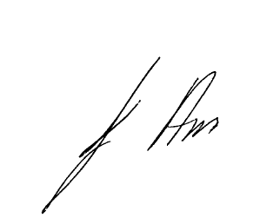
14th July 2021
Mrs J Arm – Clerk to the Council

