1

BRIDGTOWN PARISH COUNCIL
Minutes of the Parish Council Meeting.
Wednesday 26TH May 2021.
At Bethel Methodist Church following guidelines during the Covid 19 Pandemic.

Present:
Cllrs. Val Jones (Chair), Kevin Whittaker (Vice-Chair), Bob Eccleston, Peter Kruskonjic, Paul Snape.

In Attendance:
Leigh Jarratt. (Community Group).
Janine Arm. Clerk to the Council.
Ray Smythe. Assisting the Clerk.
Mandy Cook.
Leigh Jarratt.
Luis Arduino.
Martyn Buttery.
Sue Snape.

No issues were raised at the meeting by members of the public present. It was noted that prior to the meeting the Clerk had replied to an email on some questions raised but it was reported as not been received. The Clerk agreed to send a copy of the reply again.

- Election of Chairman.

It was proposed, seconded and agreed that Cllr. Val Jones would be Chairman of the Council for the following year.

RESOLVED: Cllr. V Jones to be the Chairman of the Council for the following year.

- Signing of the Chairman’s declaration of Acceptance of Office.

Cllr. Jones thanked the Council for their support and accepted the post. She duly signed her Acceptance of Office.

- Apologies received in writing prior to the meeting.

Apologies were received and accepted from Cllrs. Matthew Freeman and Maureen Freeman.

RESOLVED: To accept the apologies of above Councillors.

- Election of Vice Chairman.

It was proposed, seconded and agreed that Cllr Kevin Whittaker would be elected as Vice Chairman, Cllr Whittaker thanked the Council for their support and accepted the post.

RESOLVED: Cllr. K Whittaker to be the Vice Chairman for the following year.

- Declaration of Interests on agenda items and consideration o/f dispensations where appropriate.

Cllr. V Jones declared an interest in item 15.1. She did not vote or participate in any discussion on this issue.

- To Approve the Minutes of the Meeting held on 10th March 2021.

It was proposed by Cllr Kruskonjic, seconded by Cllr Snape and agreed to approve the minutes.

RESOLVED: Approved.

- Matters Arising from the Minutes.

The Clerk reported that following concerns that Japanese Knotweed had again been reported in the Park and Gardens, an inspection had been requested.

The District Council had already agreed to carry out a further full inspection and the Council was awaiting the results. Photographs of alleged knotweed had been shown the Council and a request was made for them to be forwarded to the Clerk to make further enquiries.

RESOLVED: Follow up with the District Council on their full inspection and the possibility of knotweed on the Park and Garden area.

Bus Service in the area: After extensive enquiries, Chaserider had advised they would be looking into routes again and would consider the viability of one through Bridgtown. The Council was advised at the meeting however, that changes had been made and Service No 1 would now be passing through Bridgtown as from 21st June 2021. The information had not been confirmed, but the Council was pleased to hear the news.
National Express had advised the X51 services had been redirected to the new Designer Outlet as it had not been financially viable in Bridgtown. They had no plans to include Bridgtown at this time but if demand showed otherwise, they would reconsider.

RESOLVED: NOTED

No further matters arose not already covered on the agenda.

- Appointment of Committees, outside representatives and Co-ordinators.

  - Parish Councils Standards Sub Committee Representative.

It was proposed, seconded and agreed that Cllr. Peter Kruskonjic would be the Bridgtown Parish Council representative on the Standards Sub Committee.

RESOLVED: Cllr P. Kruskonjic to be the representative on the Standards Sub Committee.

  - Independent Internal Auditor.

It was agreed that Linda Florence would be the Council Independent Internal Auditor for the following financial year.

RESOLVED: Linda Florence to be appointed as Independent Internal Auditor.

- Chairman’s Report.

The Chairman gave her report SEE APPENDIX 1

- Consideration of reports received from the PCSO.

The PCSO reports had been submitted and was noted.

Concerns had also been expressed on Social Media that there were problems with drug use in the area. The police reported that although drug abuse had been witnessed in the area, no one had actually reported an issue direct to the police. Cannock Police encouraged use of the correct channels to report problems of this type.

RESOLVED: To encourage people to report any drug issues direct to the police.

- Recreational Areas.

  - The Leighton Memorial Garden.

    - Application for permission for Bridgtown Community to erect a Christmas Tree in December on Leighton Memorial Garden.

RESOLVED: It was proposed, seconded and agreed that Bridgtown Community Group could erect a tree on Leighton Memorial gardens if a current Health and Safety report and Risk Assessment report was presented to the Council by 1st December 2021. If this was received to the satisfaction of the Parish Council, then the Public liability of the Parish Council insurance would cover the tree.

  - War Memorial.

No issues arose

  - Memorial Park & Gardens in Union Street.

Following the District Council advising they would be repairing the vandalised walls at Bridgtown Park and Memorial Gardens, work had commenced. However, some of the bricks were missing and would have to be replaced to complete to Work.

An appeal had been made for the missing bricks as it was assumed that they had been put away for safe keeping, no one had claimed to have had them. Cllr. Eccleston claimed there were none missing as they were scattered around the park.

It was noted that the District Council, if needed would replace the missing bricks.

RESOLVED: Noted.

- Consideration of reports From Leigh Jarratt on issues arising in local community groups.

Adjournment of the meeting to receive the report of ‘Bridgtown Community Group’ and ‘Friends of Bridgtown Park’.

RESOLVED: It was proposed, seconded and agreed the meeting would be adjourned to receive local community group reports.

  - Bridgtown Community Group.

Mr Jarratt reported he was now stepping down from the Bridgtown Community Group to concentrate on Friends of Bridgtown Park and Gardens.

  - Friends of Bridgtown Park and Memorial Gardens.

Mr Jarratt reported that It was hoped to paint the play equipment and benches in the very near future. New plants would be purchased. Coping stones would be replaced and repaired. Following the back slats of the benches being vandalised by splintering the wood, they had been reported and repaired by the District Council.
Mr Jarratt also reported that a need for CCTV had been identified and it was hoped that the Council would consider this issue.

Sue Heath had on several occasions re-planted the area at her own cost, but unfortunately the plants had been trampled down. It was hoped a grant request for a substantial planting programme would be considered favourably.

Mr Jarratt was thanked for his excellent report.

RESOLVED: the meeting was reconvened.

- Planning:

All planning issues have been circulated to Councillors for comment. No comments for note have been received within the deadline.
  - Applications for Consideration.
  - Applications Approved/Rejected by District Council.

RESOLVED: NOTED

- Correspondence.

  - Incoming.
  - Outgoing.

RESOLVED: All relevant post had been noted.

- Accounts.
  - Accounts for Consideration.

HMRC - Tax and NI contributions £1.60 due – (Clerk paid via bank transfer and reclaimed) | £0.00
Janine Arm - Clerk pay - | £374.64
Staffordshire Pension Fund 'SCC Superannuation fund | £62.14
Staffordshire Pension Fund 'SCC Superannuation fund | £62.14
Janine Arm - Clerk Expenses - postage/mileage Plus £8.03.paid to CCDC for license to cultivate. £44.39 Toner Cartridge. £1.60 to HMRC. £5.40 for mileage and postage | £59.42
Bethel Methodist Church Hall Hire | £20.00
Chairman’s allowance | £500.00
Independent Internal auditor - Linda Florence | £80.00
TOTAL Expenditure | £1,158.34

RESOLVED: Authorisation of the accounts presented for payment totalling £1158.34 was agreed.
The Clerk was thanked for her work on the accounts.

  - Consideration of the Current financial situation of the Council.

It was agreed that the accounts presented as below, represented an accurate summary of the Council’s accounts as of the last bank statement received on 1st May 2021. It was proposed, seconded and agreed to accept the accounts.

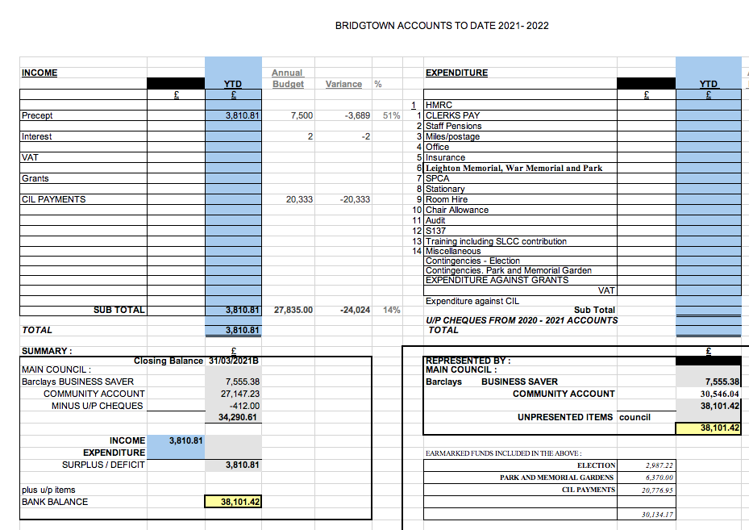
RESOLVED: To Approve the Accounts.

  - Consideration of adopting CIL Proposal Forms for expenditure on future projects.

RESOLVED: It was proposed, seconded and agreed to adopt the CIL expenditure proposal forms.

  - Consideration of any Infrastructure projects.

    - Funding proposal for CCTV on Bridgtown Memorial Gardens and Park and issues regarding monitoring and maintaining.
A proposal was made to spend some of the money the District Council had transferred, for Community infrastructure projects (CIL) in the village.

A budget of £15,000 was agreed from the CIL funds, towards the cost for refurbishing the Park to make It a more attractive and safer place for the residents of Bridgtown. This would include installing CCTV and replacing three bins. Please see Appendix 2 for copy of full proposal.

Cllr. R Eccleston requested his objection to this proposal be noted and his vote against it.

RESOLVED: A budget of £15,000 for refurbishment of the Park and Memorial Gardens.
Cllr. Eccleston objection to this proposal was noted as requested.

    - Funding replacement litter bins on Bridgtown Memorial Park and Gardens.

It was agreed that this agenda item had been dealt with within the previous Agenda item.

RESOLVED: NOTED.

    - Grant funding Proposal request from ‘Friends of Bridgtown Park and Memorial Gardens’ for purchasing plants and seeds for the park.

Friends of Bridgtown Park was a newly formed group including Residents in partnership with the Parish Council and District Council. The Group had identified another key piece of work in refurbishing the park with a need for landscaping and planting of shrubs and flowers. Sue Heath a local resident and accomplished gardener had agreed to supervise this project. A budget of £1,000 was agreed for this project.

Cllr. R Eccleston requested his objection to this proposal be noted and his vote against it.

RESOLVED: A budget of £1,000 for re planting shrubs and plants in the Park and Memorial Gardens.
Cllr. Eccleston objection to this proposal was noted.

- Consideration of 2020 2021 Audit Matters.

  - Consideration of Approval of End Of year Accounts.
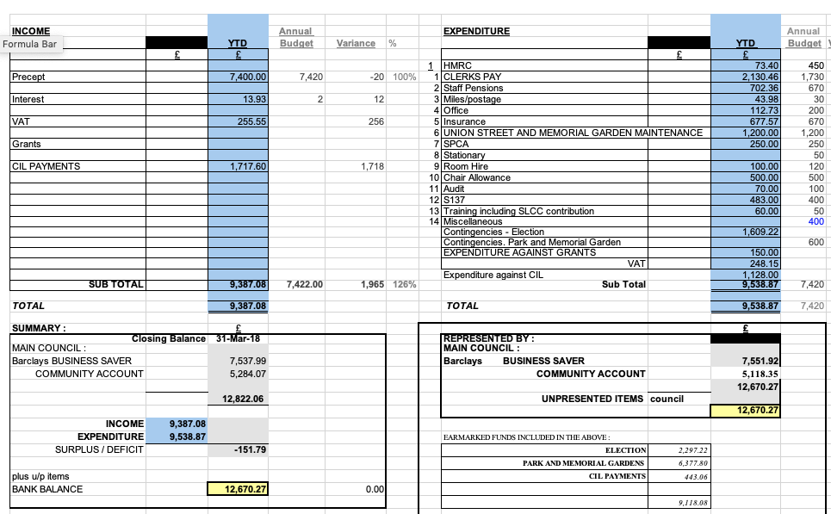

It was proposed, seconded and agreed that agreed that to the best of their knowledge the accounts fairly represented the financial situation at the end of the financial year 1st April 2020 – 31st March 2021.

RESOLVED: To approve the End of Year Accounts.

  - Consideration of the Annual Internal Audit Report.

The report was noted.

RESOLVED: To approve the Annual Internal Audit report.

  - Consideration of Approval of the Annual Governance Statement.

RESOLVED: To Approve the Annual Governance Statement.

  - Consideration of Approval of the Accounting Statements.

RESOLVED: To approve the Annual Accounting Statement for 2020 - 2021

- Consideration of reviewing Council policies and procedures.

  - Standing Orders.

RESOLVED: To approve the Standing Orders with no amendments.

  - Data Protection.

RESOLVED: To defer this item to make further enquires with a view to taking up the offer of the County Council to act as the Parish Council data Protection Officer and all that is involved.

  - Freedom of Information.

RESOLVED: To Approve Freedom of Information document with no amendments.

  - Financial Regulations.

RESOLVED: To Approve Financial Regulations with no amendments.

  - Clerk Contract.

RESOLVED: To approve the Terms of the Clerks Contract for the following year.

- Highways Issues.

The Clerk informed the meeting that she had reported the lack of communication from Severn Trent Water authority, following sewer work on Bridge Street, Bridgtown. They had written back apologising for lack of communication and explained that Highways were also carrying out major roadworks which had complicated the matter of communication. They had also provided an email for any future issues.

  - Report from Cllr. Paul Snape regarding Highways issues including problem of HGVs in weight restricted roads and consideration of working with highways and funding additional road signs.

A report was from Cllr Snape was noted including.
- Although a lot of the Highway was under the remit of Staffordshire County Council Highways. The A5 through Bridgtown, being a trunk road was under the remit of Highways England. This made it sometimes difficult for members of the public to find out planned work or current situation.

- It was agreed that HGV’s had been breaching weight restriction orders and reported but it had not seemed to alleviate the problem.

RESOLVED: It was agreed to seek advise on possible alternative options for weight restriction compliance.

- It was also noted that signs to say ‘unsuitable for HGV’s’ would not be allowed to be put up, unless the road met certain criteria.

- Confidential Item – exclusion of press and public.

Members of the Press and Public were excluded from the meeting whilst the confidential item was discussed.

- Items for Information or Future Agendas.

  - Future Agendas

Data Protection
Code of Conduct.

RESOLVED: TO ENTER THE ABOVE ON THE AGENDA.

21. Date of Next Meeting.

It was agreed that the next meeting would be 14th July 2021. Everyone was thanked for their attendance and the meeting was then closed at 8.35pm.

RESOLVED: NEXT MEETING 14th July 2021

APPENDIX 1
AGM
Chairman’s report
May 26th 2021

This report covers the period of May 2020 to May 2021. The Parish Council continued to meet on Zoom during Covid with almost 100% attendance.

Appointments & Resignations
- January 2020 the well-respected Chair, Eddie Smith retired after 30 years’ service. Ally Smith was elected to the post.
May 2020 Cllr Bob Eccleston was co-opted on to the Parish Council into this vacancy.
- November 2020 Cllr Ally Smith resigned from the Parish and Cllr Val Jones was elected as Chair.
- January 2021 Cllr Maureen Freeman was co-opted onto the Parish Council

Business as usual
Parish Councillors have responded to complaints and concerns from residents on a range of issues from noise pollution and businesses operating conditions to bin collections. Sometimes there is confusion in the public around which tier of local government has responsibility for addressing the problem ie Parish, District or County. The MYStaffs App is a useful tool as it ensures that the complaint automatically goes to the correct authority and provides a reference number to follow up on. Making a complaint third hand can mean the councillor going back and forth between the complainant and the responsible authority. The Parish Council also supported the Village Xmas celebrations led by Cllr Bob Ecclestone, with a grant to the Bethel Church for the Christmas gifts for the children at the Santa Sleigh ride.

Main Concerns
Two main concerns made to the Parish Council from residents have been the condition of the Parks and Open Spaces and the HGV traffic through the village. Due to the size of the Parish (we are the second smallest in Cannock Chase) this is reflected in the Parish precept and consequentially its budget. However, The Parish Council has been fortunate in being allocated funds from the Community Infrastructure Levy (CIL) as a result of the recent developments of Lakeside Boulevard and Walkmill Lane. This can be used to make improvements provided they meet the regulations for CIL and do not incur costly maintenance that would be difficult to meet from a limited Parish budget.

Developments for Parks and Open Spaces: -

- Parks & Open Spaces Survey – A request was made to the District Council that they undertake a survey of Bridgtown Parks and Open Spaces beginning with Bridgtown Memorial Park and Gardens as a first priority. This was undertaken by Lynn Evans, Community Education Officer, Leigh Jarrett, Cllr Val Jones, Cllr Peter Kruskonjic, along with other members of the District Parks Team. As a result, a schedule of improvements was agreed which are being actioned at this time and are noted in the report from the Chair of the “Friends of Bridgtown Park” which will become a core agenda item.

- Friends of Bridgtown Park - Members of this newly established group also include myself and Cllr Peter Kruskonjic. It is chaired by local resident Leigh Jarrett and other members are listed in his preliminary report. Much of my time since our last meeting has been spent liaising between the Friends Group and the District and Parish Councils and working with the Chair. There will be some proposals made to the Parish Council to fund the improvements.

- Incidences of Vandalism – A report has been made to the Police about the vandalism to Bridgtown Park which has resulted in significant damage to the walls of the raised flowerbeds and two of the benches which are currently being repaired by the District Council at the request of the Parish Council. The local PCSO has made several visits to the Park and has reported on her findings. They will continue to visit the Park whenever they are on duty. In addition, Cllrs Val Jones and Peter Kruskonjic have visited the Park on several occasions. As a more permanent deterrent to the vandalism, the Parish Council will be proposing the installation of CCTV linked to the District Community Safety Hub which has 24hr monitoring and a direct link to the Police.

HGV & Traffic problems
This has become a problem for Bridgtown with its proximity to the A5 with vehicles using it as a shortcut. A proposal is to be made to Highways by County Cllr Paul Snape for installation of “Not suitable for HGV” signs at critical points. Whilst it is not legally enforceable it should provide some deterrent to HGV drivers. Request will be made for undertaking another traffic survey where it is felt to be the most problematic.

Parish Council Website – The Parish Council now has an official website thanks to the efforts of the Parish Clerk and Ray Smythe. This will be for official announcements and communications from the Parish and will be managed by the Parish Clerk.

Key relationships
The Parish Council has long key standing relationships with two Bridgtown institutions, the Bethel Church through Jan Burns from the Bridgtown History Society. The Parish is pleased to support Bethel Church and will look to Jan Burns for ways in which we can do this as the Church has been at the centre of many village events. Similarly, David Williams for the History Society.

Next Year Projects to be working towards
- Completion and consolidation of the renovation project for Bridgtown Memorial Gardens Park and ensure that the remaining Parks and Spaces are also surveyed for improvements
- Identify appropriate funding projects for the CIL money that benefit residents
- Increased use of the new Parish Council website and promotion of the Parish Council and its work.

APPENDIX 2
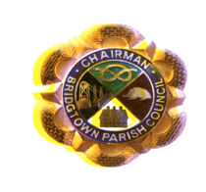 |  |  |  | Bridgtown Parish Council  Community Infrastructure Levy Proposal Form
CCDC CIL Guide for Parish and District Councils
“There is a duty to spend CIL income on providing, improving, replacing, operating or maintaining infrastructure that supports the development of the Local Council area or anything else concerned with addressing the demands that development places on the area. For example, Flood defences, Schools & other educational facilities, Sporting and recreational facilities, Open spaces”
THIS SECTION TO BE COMPLETED BY THE PROPOSER
Name of Proposal: |  |  | Renovation of Bridgtown Memorial Gardens & Play Park |  |  |  |  |  |  |  |  |  |  |  |  |  | Date:  26.05.21
Description of Proposal:

Bridgtown Park is in a poor state of repair and the Parish Council is asked to agree in principle a sum of money to make improvements to the Park which will include replacement of the bins which are disintegrating and CCTV to address vandalism concerns and any other items required to renovate the Park. The aim is to make the Park an attractive place for residents to visit, families to visit, children to play and which they can feel proud of.

Proposal: To agree budget of £15,000 for renovation and CCTV security measures of Bridgtown Memorial Park Gardens between Park Street and Union Street.
Does Proposal meet CIL criteria. Please tick answer |  |  |  |  |  |  |  |  |  |  | YES X |  |  |  |  | NO
Which residents are most likely to benefit: Please tick answer
Children | X |  |  |  | Adolescents |  | X |  | Adults |  | X |  |  |  |  |  |  |  | Elderly |  | X
Other:
What will the benefits be:
- A central focus for families and others to visit and enjoy
- A safe area for children to play and for mothers to take their children
- A venue to celebrate national promotions such as British Royal Legion commemorations, Dementia week etc
- A venue to hold local festivities
- The Park will have a small sensory garden which will be attractive for those with sensory disabilities
- Having access to an attractive garden environment can promote general well being
- An area of pride for the village.
Capital costs - Initial cost or outlay |  |  |  |  |  |  |  |  |  |  |  |  |  |  |  |  | £15,000
Revenue – total ongoing costs as listed below |  |  |  |  |  |  |  |  |  |  |  |  |  |  |  |  | £
Maintenance |  | £ 0.00 |  |  |  | Inspection |  |  |  |  |  |  | £ |  | Insurance |  |  | £
Any Other costs?
Any maintenance costs will be the responsibility of the District Council
THIS SECTION TO BE COMPLETED BY THE PARISH COUNCIL
Authorisation by Parish Council Please tick answer |  |  |  |  |  |  |  | YES APPROVED 26TH MAY 2021 |  |  |  |  |  |  |  |  | Date: 26TH MAY 2021
If No Reason for Rejection:
Authorisation by the CCDC CIL / S104 Please tick answer |  |  |  |  |  |  |  |  |  | YES x |  |  |  | NO |  |  | Date: 18.05.21
If No Reason for Rejection
Actions: - List any actions required
What |  |  |  |  |  |  |  |  |  |  |  | By Whom |  |  |  |  |  |  |  | By When
Itemised Costs to Parish Clerk |  |  |  |  |  |  |  |  |  |  |  | Cllr Jones |  |  |  |  |  |  |  | July meeting

