1

BRIDGTOWN PARISH COUNCIL
Minutes of the Parish Council Meeting.
Wednesday 10th March 2021.
Held as a virtual meeting following guidelines during the Covid 19 Pandemic.

Present:
Cllrs. Val Jones (Chair), Kevin Whittaker (Vice-Chair), Bob Eccleston, Matthew Freeman, Maureen Freeman, Peter Kruskonjic, Paul Snape.

In Attendance:
Leigh Jarratt. (Community Group). Janine Arm. Clerk to the Council. Ray Smythe. Assisting the Clerk.

No issues were raised by members of the public prior to the opening of the meeting.

1. Apologies received in writing prior to the meeting.

The meeting began at 7.12pm. No apologies had been received. Cllr Jones welcomed Cllr Maureen Freeman back to the Council following her recent co-option.

2. Declaration of Interests on agenda items and consideration o/f dispensations where appropriate.

No interests had been declared.

3. To Approve the Minutes of the Meeting held on 13th January 2021.

It was proposed by Cllr Kruskonjic, seconded by Cllr Snape and agreed to approve the minutes.

RESOLVED: APPROVED.

4. Matters Arising from the Minutes.

4.1 It was agreed to contact Cannock Chase Council to ask for any updated information regarding Japanese Knotweed in the area.

RESOLVED: TO CONTACT CANNOCK CHASE COUNCIL.

4.2 It was reported that an appropriate Risk Assessment regarding the 2020 Christmas tree had been received.

No further matters arose not already covered on the agenda.

5. Chairman’s Report.

Cllr Jones reported:
- Following her recent operation, the Clerk, Janine Arm was recovering and hoped to fully resume her duties in the near future. Ray Smythe was temporarily assisting with this meeting and some communications.
- During discussions with Bridgtown Primary School to assist with the provision of laptop computers, a government initiative had allowed the acquisition of sufficient equipment and no further financial assistance was needed from the Parish Council at this point.
- Cllr Jones has assisted Bethel Church about a need for replacement and a successful application to Cannock Chase Lions had resulted in a grant of £250 being given.
- A draft form for the proposals for use for Community Infrastructure Levy money had been devised and the Council looked forward to identifying partners, funding sources and projects in the future for the benefit of the area.

6. Consideration of reports received from the PCSO.

The PCSO report had been submitted and was noted. It was agreed to publicise local thefts of catalytic converters on Facebook for information.

RESOLVED: TO PUBLICISE THE INFORMATION ABOUT LOCAL THEFTS.

7. Consideration of adopting the Councillor Code of Conduct 2020.

The document had been circulated and it was proposed, seconded and unanimously agreed to adopt the Code.

RESOLVED: TO ADOPT THE CODE.

8. Recreational Areas.

8.1 The Leighton Memorial Garden.
8.2 War Memorial.
8.3 Memorial Park and Garden in Union Street.

No issues arose.

8.4 Consideration of the Village Upgrade Working Committee; it’s role and responsibilities.

It was agreed that following the creation of the community group, that there was no need for this committee as any suggestions could be forwarded to the Council for consideration. This could be reviewed should the position change. The Council would welcome any reports from the Group and these would be circulated and considered as and when received. It was agreed to enter a standing item on the agenda to cater for this. The Committee was therefore suspended.

RESOLVED:
- TO ENTER A STANDING AGENDA ITEM TO ALLOW CONSIDERATION OF ANY REPORTS FROM THE GROUP.
- TO SUSPEND THE COMMITTEE.

8.5 Consideration of Village initiatives to benefit the Parish.

Cllr Jones welcomed Leigh Jarratt to the meeting and thanked him for forwarding the minutes of the Community Group meeting.

Mr Jarratt said that the Group had been formed to improve the area and would work independently on projects and with the Parish Council where relevant to pursue this aim.
The following would be considered:
- Newsletter. (support for local businesses).
- Offer to deal with reports of abandoned hypodermic needles via sharps boxes.
- Christmas events (Carnival, Market and Sleigh Ride). Possibly 11th December.
- Repainting Cannock Chase Council play equipment subject to their consent.

Cllr Jones expressed the support of the Council for the Group’s aims and projects and Mr Jarratt was thanked for his report and his positive contribution.

9. Planning.

9.1 Applications for Consideration.

Applications were considered and noted.

9.2 Applications Approved/Rejected by District Council.

Applications approved, rejected or withdrawn would be noted.

10. Correspondence.

10.1 Incoming.
10.2 Outgoing.

All reported post had been noted.

RESOLVED: NOTED.

11. Accounts.

11.1 Accounts for Consideration.

  - Accounts for Consideration.

HMRC - Tax and NI contributions (none due) | £0.00
Janine Arm - Clerk pay - | £374.64
Staffordshire Pension Fund 'SCC Superannuation fund | £62.14
Staffordshire Pension Fund 'SCC Superannuation fund | £62.14
Janine Arm - Clerk Expenses - postage/mileage Plus £3,00 paid on line to HMRC for tax due. | £9.40
Bethel Methodist Church Hall Hire - no meeting in Hall | £0.00
Staffordshire Parish Councils Association | £60.00
Cannock Chase Shed - S137 grant | £100.00
Staffordshire parish Councils Association - Annual Subscription | £252.00
TOTAL Expenditure | £920.32

11.2 Current financial situation of the Council.

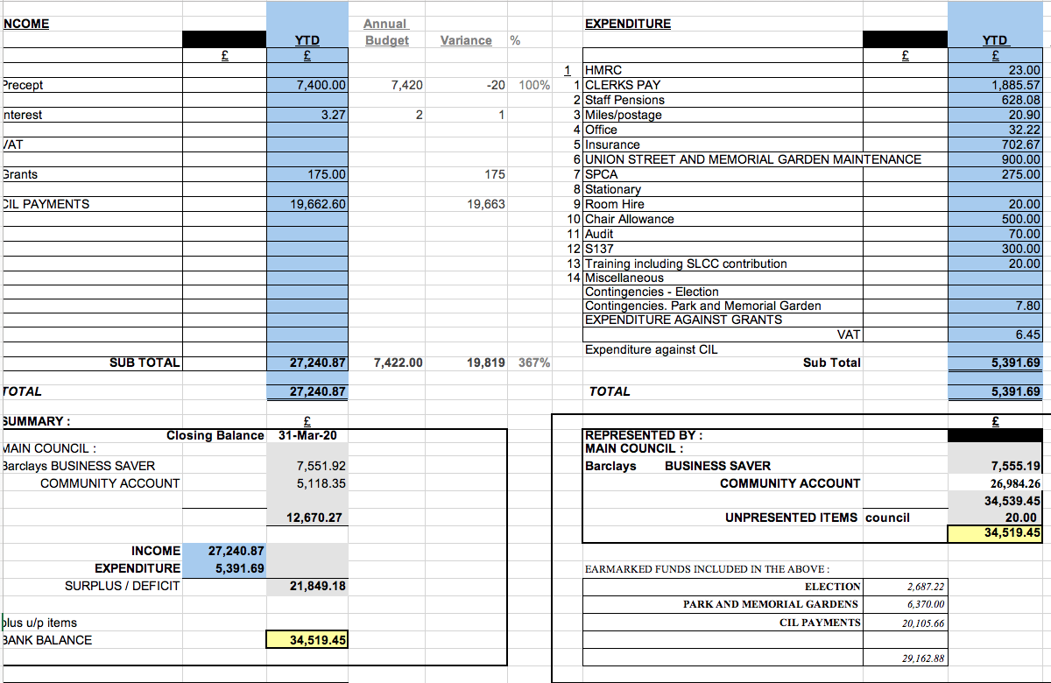

It was agreed that the accounts for payment presented, represented an accurate summary of the Council’s accounts. It was proposed, seconded and agreed to accept the accounts.

RESOLVED: TO APPROVE THE ACCOUNTS.

11.3 Consideration of suitable infrastructure projects for the next five years

It was agreed to consider suitable projects.

12. Highways Issues – matters arising for attention.

Cllr Snape gave the meeting information about potential costs so projects could be viewed realistically and prioritised if applicable. These were not for specific locations but as a general guide.

- Guard rails (such as at schools) £750.
- Double Yellow lines - £5,000.
- Bollards £150 each.
- Dropped kerb £2,000.
- 10 metres of footpath - £7,000
- Pelican Crossing up to £100,000
- Zebra Crossing from £30,000 to £60,000.

Cllr Snape was thanked for his useful information.

13. Consideration of Parish Council communications, public relations and promoting the works of the Parish Council, including the content of the new website.

13.1 Cllr Jones had circulated an email inviting suggestions for any changes to existing communication arrangements but none had been received.

13.2 It was reported that the Council was populating a new website hosted by the County Council.

13.3 It was agreed to look at meeting locations when physical meetings are reconvened.

14. Items for Information or Future Agendas.

14.1 Future Agendas

- Consideration of arrangements for virtual meetings.
- Bus services in the area.

RESOLVED: TO ENTER THE ABOVE ON THE AGENDA.

14.2 For Information: No issues raised.

15. Date of Next Meeting.

It was agreed that the next meeting would be 12th May 2021. Everyone was thanked for their attendance and the meeting was then closed at 8.35pm.

RESOLVED: NEXT MEETING 12TH MAY 2021.

APPENDIX 1 (Agenda 8.5.1).

Provided by Bridgtown Community Group.

(Fact Check. There is no ban on businesses advertising on the Bridgtown Past and Present Facebook Group).

Bridgtown Community Group Meeting Minutes.

Introduction to the purpose of the group, what we hope to achieve and how we intend to go about achieving our aims.

Meeting was attended by residents and businesses from across Bridgtown. The introduction outlined the start of a community group ran by the community to deliver services and projects within Bridgtown for the benefit of residents and Businesses alike. Open offers to utilise the Bethal and Bridgtown Social club as the Hub proposed.

Utilising the Support of the Parish Council and the best format to raise issues, concerns or suggestions.

Proposal for the formation of a resident’s group on behalf of the Parish council was met with a negative response, it has therefore been decided the Community Group will remain independent of the Parish Council for the time being. It was however agreed that working in unison with the Parish Council was in everybody’s best interests and to try and utilise the Parish’s support where possible. The meeting was attended by Cllr Bob Eccleston who will be the connection between the Community Group and the Parish Council.

Open issues
Local businesses – How best to support & promote.
- Concerns raised over the ban of local businesses advertising on Bridgtown Past & Present Facebook page, it was however explained that this page was independently run, and its content was outside any control of the Parish Council or Community Group. A separate page ‘Bridgtown Community “Embracing Change” is open to local businesses to advertise services & products. https://www.facebook.com/groups/2853523161543213
- Further suggestions included selecting one business per week for an in depth introduction to their business including more about the owners, their history in Bridgtown and the services / products they offer.
- Community Group to look into a monthly newsletter distributed to all residents in Bridgtown to include News of the Community, a Bridgtown history segment & advertising for businesses.
- Community Group to compile an Index of local businesses with a short summery of services offered to promote ‘buying locally’.
Discarded needles – Safety issues, how to report and further actions.
- Advice offered that should any discarded needles be sighted, do not attempt to dispose of, instead please report to Local Police, Cllr Bob Ecclestone or Leigh Jarratt who are in possession of sharps boxes which can be disposed of correctly.
Local Crime – How to discourage, Report and reduce.
- Advice offered to ensure cars and properties are locked at all times and to immediately report suspicious behavior to local police.
Followed by open discussion.

Community Ideas
Christmas sleigh ride / mini-Carnival.
- Proposal to expand upon the success of the Christmas Sleigh Ride into a mini Christmas Carnival. Cllr Bob Eccleston to look into possible road closures to accommodate. Community Group to approach local businesses, School and residents for participation. Firm date TBC.
Litter picking, general tidy.
Periodic Litter picking across areas of Bridgtown to be coordinated by Ashley Clarke. Thesee will be announced on Facebook prior to the event appealing for volunteers. Community group to approach local businesses for the supply of litter pickers, gloves & Bags.
Disposal of waste to be coordinated with Council. Alternatively Marie from Bridgtown Social club has kindly offered the use of the bins.
Local Park, improvement ideas.
- Community Group to coordinate planting to the Garden areas in the park and the re-painting of park equipment. Possibility of adding additional equipment to the park discussed and to be proposed to the Parish Council. It was discussed that the possibility of taking back the lease for the park from Cannock Council would not be a possibility due to the maintenance costs the Parish could not afford.
Volunteer group.
- List to be compiled of Volunteers willing to participate in community events. All events will be made public on Bridgtown Facebook groups appealing for volunteers. Mencap have several volunteers for community events.
Bridgtown Community Facebook Page.
Dedicated Facebook group of the community set up, we would encourage as many residents and Businesses to join the group to keep appraised of events and announcements.
Follow link - Bridgtown Community "Embracing Change" | Groups | Facebook
Followed by open discussion.

Any other business
Open to all attendees, whether Businesses or residents to suggest ideas or concerns that could have an impact on the village.

