1

BRIDGTOWN PARISH COUNCIL
Minutes of the Parish Council Meeting.
Wednesday 13th January 2021.
Held as a virtual meeting following guidelines during the Covid 19 Pandemic.

Present:
Cllrs. Val Jones (Chair), Bob Eccleston, Matthew Freeman, Peter Kruskonjic, Paul Snape and Kev Whittaker.

In Attendance:
Clerk, Janine Arm.

Due to the confidential nature of Item 3 of the Agenda, Members of public were not admitted to the meeting room until after this item had been dealt with. No issues were raised by members of the public prior to the opening of the meeting.

- Apologies received in writing prior to the meeting.

No apologies had been received.

- Declaration of Interests on agenda items and consideration o/f dispensations where appropriate.

No interests had been declared.

RESOLVED: Noted.

- CONFIDENTIAL ITEM Consideration of Councillor Vacancy.

It was reported that four applications for the post of Councillor had been received. After lengthy consideration, it was agreed that Maureen Freeman would be invited to join the Parish Council.
It was noted that all four applications had been excellent and had proved a difficult decision. All applicants would be thanked for their interest and invited to apply for any future vacancies.

RESOLVED: To Co-opt Maureen Freeman.
To write to the other candidates and thank them for their applications.

The meeting was temporarily adjourned as Members of the public were accepted into the meeting.

- To Approve the Minutes of the Meeting held on 11th November 2020.

It was proposed, seconded and agreed to approve the minutes.

RESOLVED: To approve the Minutes.

- Matters Arising from the Minutes.

It was noted that as agreed the Clerk had sent in a Precept request to Cannock Chase Council. Provisional figures had indicated that on a £7,500 precept, the Band D Equivalent would be £11.87 per annum which meant a 5% decrease.

No further matters arose not already covered on the agenda.

- Chairman’s Report.

Cllr. Val Jones had presented the following written report for consideration.
- JP Alloys - Long standing complaints regarding noise pollution reportedly from a Fan used by JP Alloys out of hours. Investigation by Environmental Health who could not confirm this however J P Alloys were warned about the use of the Fan. This remains an open enforcement case.
- Bennick Trading Estate - The operating out of trading hours reported problems here have become confused with the noise from the Fan from JP Alloys out of hours. However, I have requested sight of the planning agreement for the operating hours of the businesses on this site.
- Lakeside Boulevard Open Space – Report to the senior planning officer following a complaint regarding waste bins not being collected from CCDC marked bins situated in the open space from Cllr Ecclestone. This service has not yet been adopted by CCDC and therefore responsibility is still with the developers. They were contacted that evening and sent an immediate apology to the Parish Chair.
- CCDC Corporate Plan 2021 – 2024 Survey - Invitation was sent to Parish Councillors to complete a snapshot survey on corporate priorities.
- Focus Group – invitation for residents to participate in online focus groups. Notification was not received by the Parish until 17th November day before one the first group on the 18th and the second on the 24th. This left little time for the Parish to notify residents.
- Army Reserve Forces & Cadets – As the CCDC representative for the Army Reserve Forces & Cadets the Chair has made connect with headquarters in Birmingham to establish a connection with the Centre in Bridgtown.
- Xmas Window Display initiative – contact made with Fred Pritchard around the possibility of using business premises for a Xmas window display of winning pictures in a children’s picture competition. This worthy initiative proposed by Alison Smith, the previous Chair, was not possible due to insufficient premises, lockdown restrictions and the school timetable. Something to plan for next year.
- Santa Sleigh Ride – Congratulations to Cllr Ecclestone who was the principal organiser and main player, of this memorable event for children in Bridgtown. Presents were delivered to children by elves. Attended by the Parish Chair and Cllrs Kevin Whittaker and Peter Kruskonjic.
- Looking After Those Around Us – email from County Cllr Victoria Wilson , Cabinet Member for Communities and Culture. This letter lists the support available and the ways in which Parish Councils can work with and develop community groups particularly during the Covid pandemic. This will be an Agenda item for the March Parish meeting.

- Consideration of reports received from the PCSO.

The PCSO report had been submitted and noted.
The Chairman, Cllr Val Jones had written and requested information about the status and confidentiality of the reports and was awaiting a reply.

It was noted however that there appeared to be a lot of car crime in the area. It was agreed to advertise a “Please Secure Your Vehicle” post on social media.

RESOLVED: PCSO Crime report noted.
Advertise ‘Please Secure your Vehicle’ on social media.

- Recreational Areas.

  - The Leighton Memorial Garden.
    - Consideration of Replacing the coping stones in the Garden.

Cllr. Eccleston report that the coping stones would be replaced by a community initiative in the summer and would not have any cost implications.

  - War Memorial.
No issues arose.

  - Memorial Park and Garden in Union Street.
    - Consideration permissions needed from the District Council for residents getting involved with the Park.
The Parish Council did not have a lease nor any control of this park and gardens and any voluntary work would have to be ratified with the District Council. Cllr. Eccleston reported that the Council had permissions to carry out some general gardening and clearing work and also permission to repair coping stones.

It was noted with thanks that Sue Heath, a local lady, had been planting in the garden. Unfortunately the garden plants had been vandalised and pulled up but she had subsequently replaced them. She hoped to be able to plant out again this year to improve the area.

Concerns were also expressed regarding the knotweed, Cllr. Eccleston said he had reported this to the District Council and that a resident had offered to address the problem, but the District Council had not taken up this offer. Cllr, Val Jones offered to follow up this issue with the District Council.

RESOLVED: To ascertain the current situation regarding the reported knotweed problem in the Park.

    - Bee attracting seeds in the Memorial and bedding plants for the garden.
It was noted with thanks that Sue Heath, a local lady had been planting out and hoped to continue to do so. It was also hoped to plant more bee attracting seeds.

- Planning.

  - Applications for Consideration.

Applications were considered and noted.

  - Applications Approved/Rejected by District Council.

Applications approved, rejected or withdrawn would be noted.

- Correspondence.

  - Incoming.
The Council had received notification regarding a change of provider of the bus service in Bridgtown. The service would now be run by Chaserider and they had agreed to circulate the new bus timetables in strategic areas, especially in Vine Court.

There were also concerns about the lack of bus stops in the Parish especially as there were now none within the village centre. It was agreed that the Council would request that a bus route was redirected slightly and a bus stop used on North Street in the vicinity of Bridgtown Primary School, Bridgtown.

RESOLVED: To request that a bus service be run through the centre of the village with a bus stop outside the local school.

  - Outgoing.
Outgoing post had been noted.

- Accounts.

  - Accounts for Consideration.
The following accounts were presented to the Council for consideration.
HMRC - Tax and NI contributions (none due ) | £13.40
Janine Arm - Clerk pay - TWO MONTHS | £364.25
Staffordshire Pension Fund 'SCC Superannuation fund | £62.14
Staffordshire Pension Fund 'SCC Superannuation fund | £62.14
Janine Arm - Clerk Expenses - postage/mileage | £4.00
J Burton Gardening Services | £100.00
Bethel Methodist Church Hall Hire - no meeting in Hall | £0.00
J ARM £11.60 refund of tax HMRC deducted but show as a refund on next payment - £11.60 payment had not been sent to HMRC but deducted from Clerks Pay | £11.60
Bethel Methodist Church Hall S137 payment for Christmas celebrations | £150.00
Support Staffordshire - Dementia Alliance grant S137 | £150.00
TOTAL Expenditure | £917.53

Authorisation of the accounts presented for payment totalling £917.53 was proposed, seconded and agreed.

RESOLVED: To authorise the payments.

  - Consideration of the current Financial Situation of the Council.

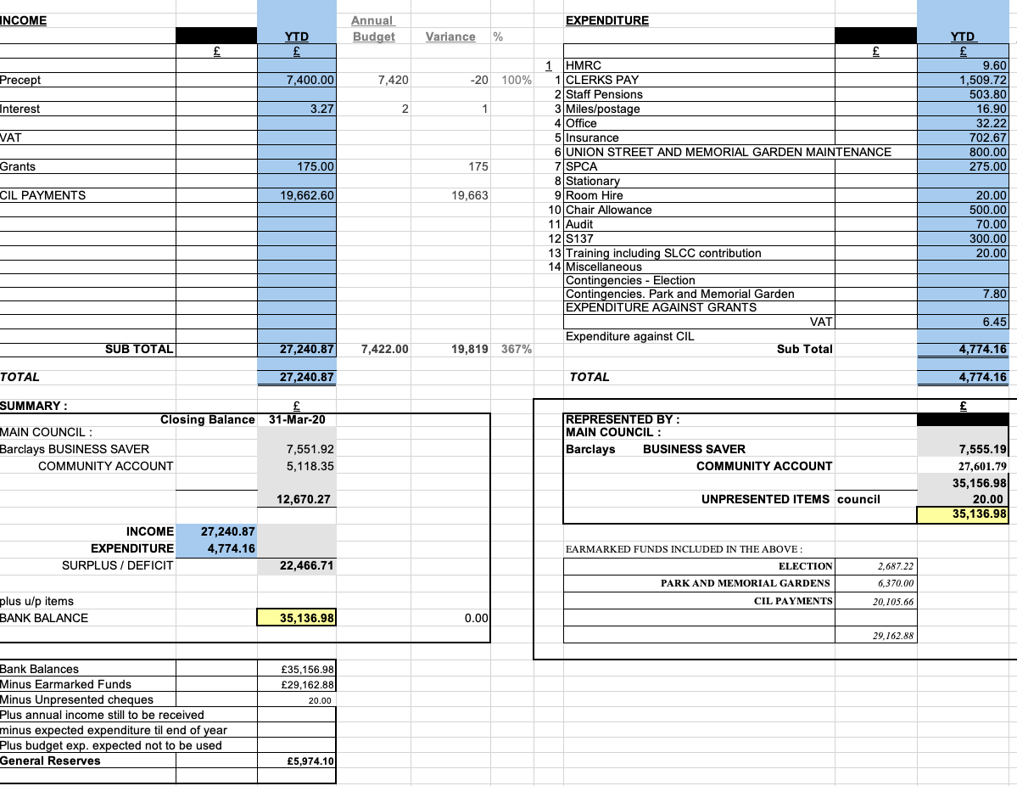
It was agreed that the accounts presented, represented an accurate summary of the Council’s accounts. It was proposed, seconded and agreed to accept the accounts.

RESOLVED: To approve the accounts.

  - Consideration of suitable Community Infrastructure Levy money. Projects for the next five years
Cllr. Paul Snape gave a brief outline of Community Infrastructure Levy money (CIL money) and what it could be used for.

Following suggestions of having signs on Lakeside boulevard stating the road was ‘Not Suitable for HGV’s’ Cannock Chase District Council had advised that this would be a suitable spend of CIL money. Cllr. Snape had made enquiries with Mark Keeling of County Council Highways and if on inspection he agrees that the road is not suitable for HGV vehicles, the Council can progress this issue.

It was agreed to consider the criteria and guidelines for spending CIL money awarded to the Council so that future projects could be assessed against the criteria.

Cllr. Bob Eccleston suggested that Concurrent Grant Aid Systems could also be looked at towards parish infrastructure projects. It was noted that the any grants given would be a maximum of 25% of total costs.

RESOLVED Clerk to make enquires regarding the grant Criteria of Concurrent Grant Aid Systems.

  - Consideration of amounts in Recreational Areas, earmarked budgets.

The Clerk reported on the Recreation Earmarked budget and projects previously funded and it was agreed that these funds could be used for village projects to improve the area.

It was agreed that the Council would form a working ‘Village Upgrade Committee’ It was agreed that Cllr Eccleston and Cllr. Whittaker would form the Working Committee. Members of the public would be invited to join the working committee. The Working Committee would report back to the Council and request authorisations and funds when appropriate.
It was agreed that Leigh Jarratt, Sue Heath and Judith _____would be invited to join the committee too.

RESOLVED: To form a Village Upgrade Working Committee.

  - Consideration of Garden Maintenance Contract.
It was noted that J. Burton (Gardening Services) had advised that due to age and health issues he was retiring. It was agreed to thank him for his service.

Leigh Jarratt, a local resident had volunteered his company to paint the play equipment at no cost to the Council in the Memorial Garden and Park. It was noted that the play equipment was District Council property, but the Clerk could forward his offer to the Parks Department.

  - Consideration of grant application from Cannock Chase Shed.

It was agreed to make a grant donation of £100 to Cannock Chase Shed, charity. The Clerk would request the direct benefit for Bridgtown residents and any promotional material they had to advise Bridgtown Residents of help available.

RESOLVED: To donate £100.

- Highways Issues – matters arising for attention.

County Councillor Paul Snape, Highways report was noted. See report Appendix 1

- Consideration of Parish Council communications, public relations and promoting the works of the Parish Council.

It was noted that the Council was awaiting a new website hosted by the County Council.

It was agreed that Councillors would send to the Clerk a short bio and photo to put on website and facebook.

It was also hoped to have a report on what the Council had achieved over the past few years.

- Consideration of Village initiatives to benefit the Parish.
  - Consideration of issues arising having hanging baskets for the local shops.

The Parish Council agreed they would support the local shops in helping with shops willing to have hanging baskets. It would be initially discussed within the new Working Committee for Village Upgrade.

Cllr. Eccleston reported that he had spoken with shopkeepers who were supportive of the scheme and money had also been raised towards the project. It was also noted that a volunteer had also agreed to donate hanging basket plants. If any funding was needed the Council would be asked.

It was noted that although it had been hoped to have a Christmas market in 2020. Due to the late request and coronavirus pandemic restrictions, this had not been possible.

  - Consideration of addressing School Vandalism.

It was noted that coping stones as discussed earlier, would be replaced in the summer.
CCTV was suggested as a possible solution.

- Items for Information or Future Agendas.

Future Agendas

New website – content suggestions.
Council achievements.
Village Upgrade Working Committee report.

Consideration of Councillor Code of Conduct.

RESOLVED: The above items on the next Council Agenda.

For Information:

Cllr. Bob Eccleston made an appeal for volunteers to help locally, to enable a roll out of the Coronavirus Vaccinations.

Cllr. Val Jones reported on general situation regarding Coronavirus Vaccinations in the area and It was hoped the four top groups would have their vaccinations by mid-February.

- Date of Next Meeting.

It was agreed that the next Meetings would be 10th March 2021.

Members were thanked for their attendance and the meeting was then closed.

APPENDIX 1
Highways report from County Councillor Paul Snape.

- Not suitable for HGV’s Signs.
These can be erected where a street is not suitable for a HGV to access but is normally only put up where persistent problems are caused by such vehicles using the street. They cost approximately £800 per sign and of course you will need one at each end (unless a one way street). They are advisory and not regulatory, so it is not an offence to ignore them.
- Bridgtown School, Longford Road, Parking Issues.
Safer Streets have been down on numerous occasions, at various times and to other locations in Bridgtown. They of course record logs of all their visits and problems found and tickets issued.
The biggest problem caused in relation to the school is by the same four vehicles. All are displaying a blue disabled badge. These vehicles park on the ZIG-Zags directly outside the school. They do not commit any offence, as they have a blue badge and are therefore not prevented from allowed parking there. However, Sue Benton, from Traffic Management, has recently written to the Acting Head-Teacher, offering advice. She has advised that the school should speak to these parent/grandparents, asking that they reconsider where they park in the interests of child safety. A letter to all parents could also be considered.
Safer Streets are now programmed in for more visits to Bridgtown school but also for other areas of the village where vehicles are parked in breach of regulations.
- Lakeside Boulevard.
Road signs should be put up either later this month or early next month opposite the Children’s’ play park, warning road users of the park and the possibility of children crossing.
- Longford Island outside No 270 Longford Road.
As you all will be aware; flooding has been taking place there for 2 years whenever heavy rain falls. The drains have been cleared and a new drain laid to the main sewer but the problems still persists. The issue is that the main sewer is totally silted up. I have requested that the Vac-Tank be used to try and clear the problem which will hopefully be used next week. The sewer runs from Longford Road, down Skipton Green towards Wellington Drive and into the culvert on Wellington Drive. This will hopefully be looked at next week, but it is not guaranteed to be successful.
- Many pavements around the Cannock South Ward are being looked at and problems rectified. This is due to COVID and trying to get people to walk as opposed to driving everywhere. This work will continue as long as the weather makes it possible.

