BRIDGTOWN PARISH COUNCIL
Minutes of the Parish Council Meeting.
Wednesday 9th September 2020.
Held as a virtual meeting following guidelines during the Covid 19 Pandemic.

Present:
Cllrs. Bob Eccleston, Peter Kruskonjic and Paul Snape

In Attendance:
Clerk, Janine Arm.

- Apologies received in writing.

Apologies were received from Cllrs Alison Smith, Val Jones and Kevin Whittaker.

- Declaration of Interests on agenda items and consideration if dispensations where appropriate.

No interests had been declared.

RESOLVED: Noted.

- To Approve the Minutes of the Meeting held on 8th July 2020.

It was proposed, seconded and agreed to approve the minutes.

RESOLVED: To approve the Minutes.

- Matters Arising from the Minutes.

An anonymous, malicious report had been made to the external Auditor claiming that they had contacted the Clerk asking for a copy of the accounts that were not shown on the internet. No such request had been received. The Auditor confirmed that no breach had been made and publishing deadlines had been observed. To date, the Clerk still has not receive any request for a copy of the accounts, all of which are available on the website.

No further matters arose not already covered on the agenda.

- Chairman’s Report.

In her absence, Cllr. Alison Smith had sent her report in writing.

She advised: - An alleged house of multiple occupancy on Church Street was reportedly not following safety guidelines and the landlord had been contacted and was now working with Cannock Council to be a legal landlord.

A house suspected of growing an illegal substance had also been reported to the police.

It was agreed to publish ‘Crimestoppers’ information on the local facebook page for anyone wishing to remain anonymous for fear of repercussions

Following further reports of noise nuisance on Union Street, Environmental Health has agreed to look at the problem.

- Consideration of reports received from the PCSO.

PCSO report had been submitted and noted. Thanks were expressed for all their hard work.

- Recreational Areas.

  - The Leighton Memorial Garden.

Debris from drain repairs had been left on the garden area and needed tidying and the garden retaining wooden strip had been damaged. Cllr. Eccleston would make further enquiries regarding repairing the area.

RESOLVED: - to repair damaged area of the memorial garden.

  - War Memorial.

The area was well maintained and there were no matters of report.

  - Memorial Garden in Union Street.

Cllr. Eccleston was thanked for his work in tidying up the park and the Memorial Garden.

A potential outbreak of Japanese Knotweed was being investigated just outside the park boundary. Environmental Health were aware. A local resident who was in the process of being registered to deal with this invasive pant with herbicides has come forward offering help. It would, of course, be dependent on the landowner’s permission.

RESOLVED: Noted.

- Planning.

  - Applications for Consideration.

Applications were considered and noted.

  - Applications Approved/Rejected by District Council.

Applications approved, rejected or withdrawn would be noted.

- Correspondence.

  - Incoming.

Bethel Methodist Church had approached the Chairman of the Council regarding having an outdoor Christmas Market due to Covid 19 restrictions. It was hoped that local businesses would also participate.

It was also noted that businesses on North Street were interested in a street Market. The Clerk pointed out that the businesses would have to consider implications and costs of Road/footway closures. Cllr. Eccleston would liaise with Cllr. Snape and advise the businesses of procedures.

Councillors also agreed to hold a Christmas Window Display competition. The monetary prize would be agreed at the next meeting.

Mr Fred Pritchard had agreed to donate a Christmas Tree.

Further complaints had been received regarding noise outside of permitted working hours Environmental health had been advised. Cllr. Jones was still following up this issue.

  - Outgoing.

No issues arose that had not already been covered on the agenda.

- Accounts.

  - Accounts for Consideration.
The following accounts were presented to the Council for consideration.

HMRC - Tax and NI contributions | £9.60
Janine Arm - Clerk pay | £408.65
Staffordshire Pension Fund 'SCC Superannuation fund ' including arrears from pay award | £75.50
Staffordshire Pension Fund 'SCC Superannuation fund | £62.14
Janine Arm - Clerk Expenses - postage/mileage | £3.00
J Burton Gardening Services | £200.00
Came & Company - annual parish council insurance | £702.67
Bethel Methodist Church Hall Hire - no meeting in Hall | £0.00
Staffordshire Playing Fields Association - annual subscription | £20.00
TOTAL Expenditure | £1,481.56

Authorisation of the accounts presented for payment totalling £1481.56 was proposed, seconded and agreed.

RESOLVED: To authorise the payments.

  - Consideration of the current Financial Situation of the Council.

It was agreed that the accounts presented , represented an accurate summary of the Council’s accounts. It was proposed, seconded and agreed to accept the accounts.
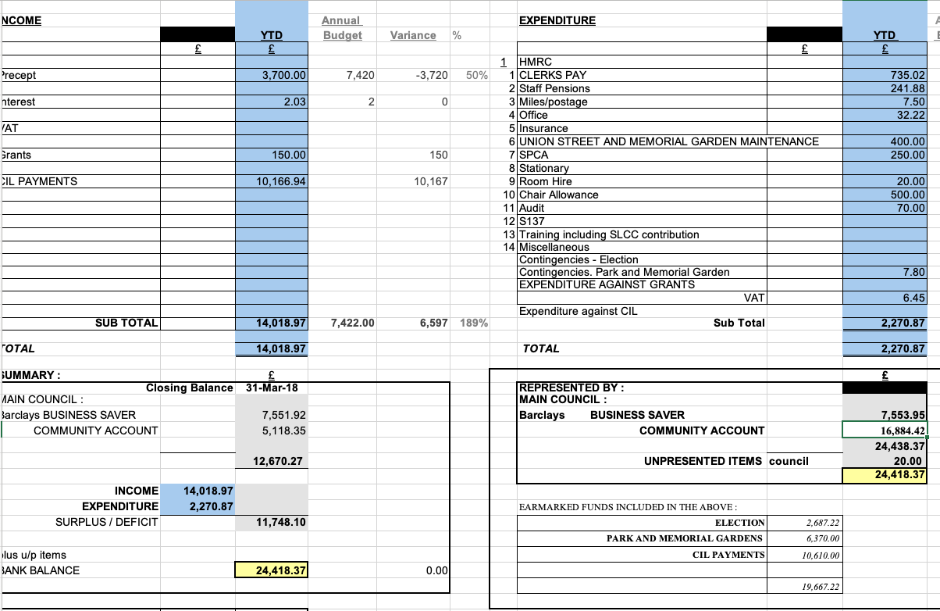

RESOLVED: To approve the accounts.

- Highways Issues – matters arising for attention.

Parking problems around East Street had been reported. It was thought to be customers leaving vehicles to a local a local car body repair shop. The issue had been reported to the PCSO.

No further issues arose, not already on the agenda.

- Items for Information or Future Agendas.
- Consideration of Council budget for 2021 – 2022 financial year
- Consideration of 2021 – 2022 precept requirements.
- Consideration of financial support for Cannock Dementia Alliance Group

RESOLVED: The above items on the next Council Agenda.

- Date of Next Meeting.

It was agreed that the next Meetings would be 11th November 2020. Members were thanked for their attendance and the meeting was then closed.

