1

BRIDGTOWN PARISH COUNCIL
Minutes of the Parish Council Meeting.
Wednesday 11th November 2020.
Held as a virtual meeting following guidelines during the Covid 19 Pandemic.

Present:
Cllrs. Val Jones, Bob Eccleston, Peter Kruskonjic, Matthew Freeman, Kev Whittaker and Paul Snape.

In Attendance:
Clerk, Janine Arm.
Three members of the public.

No issues were raised by members of the public prior to the opening of the meeting.

- Election of Chair.

Following the vacancy of Chairman, it was proposed, seconded and agreed that Cllr. Val Jones would be Chairman for the remainder of the municipal year.

RESOLVED: Cllr. Val Jones to be Chair.

Cllr. Val Jones thanked the Councillors for their nomination and support and accepted the nomination.

- Apologies received in writing prior to the meeting.

No apologies had been received.

- Declaration of Interests on agenda items and consideration if dispensations where appropriate.

No interests had been declared.

RESOLVED: Noted.

- Declaration of Councillor Vacancy.

Following the resignation of Alison Smith, the vacancy would be declared and advertised.

RESOLVED: To declare a Councillor Vacancy.

- To Approve the Minutes of the Meeting held on 9TH September 2020.

It was proposed, seconded and agreed to approve the minutes.

RESOLVED: To approve the Minutes.

- Matters Arising from the Minutes.

No further matters arose not already covered on the agenda.

- Chairman’s Report.

  - Consideration of any Christmas celebration plans including Carols around the Tree.

Deferred to item 9,1.1in the Agenda, when the Council received a report from Cllr. Bob Eccleston regarding Christmas Trees.

  - Consideration of Christmas Window Display Competition and any prize money to be awarded.

Following further discussions, it was agreed that Shop owners would be encouraged to make Christmas window displays. It was agreed that prize money incentives could be counterproductive so would not be offered, but to publicise any windows dressed.

It was agreed that should Covid restrictions be lifted in time, Bridgtown Primary School could become involved and perhaps with permissions decorate an empty shop window.

RESOLVED: To encourage local shops to have Christmas Window displays.
To Invite Bridgtown Primary School, if relevant pandemic restrictions were lifted, to consider decorating empty shop window units for Christmas.

- Consideration of reports received from the PCSO.

PCSO report had been submitted and noted and was pleased that crime seemed relatively low, but disappointing to see neighbour disputes in the area appeared to have risen. Thanks, were expressed for the PCSO’s hard work.

It was noted that PCSO Luke Peckett had been off sick due to a bike accident, it was agreed to write and wish him well.

RESOLVED: PCSO Crime report noted. To write and wish PCSO Luke Peckett a speedy recovery following his accident.

- Recreational Areas.

  - The Leighton Memorial Garden.
    - Consideration of Request from Bridgtown Community Group to display a lighted Christmas Tree on Garden area.

Cllr. Bob Eccleston had sent in a request on behalf of Bridgtown Residents to install and light a Christmas tree on Leighton Memorial Garden. Cllr. Eccleston reassured the Council on the legal and Health and Safety concerns and advised that the supply power to the low voltage lights would be on private land and backed up by the appropriate RCB circuit breakers to control power. The work would be completed by a qualified electrician and details passed onto the Clerk for their records.

RESOLVED: If relevant legal, Health and Safety precautions were in place and a risk assessment done, the Council granted permission to display a lighted Christmas tree.

Cllr. Bob Eccleston also reported on the rest of the arrangements for Christmas that Bridgtown Residents had started to make. Five trees (possibly six) would be displayed around the area. Trees had been donated by Mr Pritchard.

A 12ft tree would be displayed on Leighton Memorial Garden as detailed above.

Bethel Church on Union Street had agreed to display a tree, as in previous years and would welcome any help in dressing the tree.
A tree would be placed on A34 outside Mr Pritchard’s Care Home.
One on area by O’Malleys Family Funeral Parlour on North Street. The tree will be decorated and dressed by themselves.
It was hoped a tree will be displayed on corner of Vine Lane outside Vine Court nursing home, or in the nearby vicinity. There were problems with lighting, but contingency plans were being considered, should there be any problems in getting electricity supply to the site.

A sixth tree would be put on the The Whitehouse.

A sleigh had also been arranged to parade through the village, but Coronavirus pandemic restrictions would be a deciding factor how this could go ahead.

Bethel Methodist Church amongst other ideas will hopefully be holding a virtual ‘Carols Around the Tree Service.’ Bridgtown Community members were hoping to raise funds for the Bethel Church for some of the initiatives the Bethel were organising.

It was noted the Parish Council wished to be included and supported any Bridgtown Community initiatives.
Cllr. Bob Eccleston assured them he would keep the Council updated.

  - War Memorial.

The Remembrance Day service had been severely restricted owing to government guidelines, However the Council thanked the Royal Engineers for their excellent arrangements for a small restricted service to take place.
It was noted the area was well maintained and there were no further matters of report.
A note of thanks would be sent to The Royal Engineers Association, Royal Military Police, 116 Provo Company and the Methodist Minister at Bethel Methodist Church.

RESOLVED: To thank Royal Engineers Association, Royal Military Police and Bethel Methodist Church Minister.

  - Memorial Park and Garden in Union Street.

No issues arose.

- Planning.

  - Applications for Consideration.

Applications were considered and noted.

  - Applications Approved/Rejected by District Council.

Applications approved, rejected or withdrawn would be noted.

- Correspondence.

  - Incoming.
Incoming post had been noted and circulated.

  - Outgoing.
Outgoing post had been noted.

- Accounts.

  - Accounts for Consideration.
The following accounts were presented to the Council for consideration.

HMRC - Tax and NI contributions (none due )
Janine Arm - Clerk pay - TWO MONTHS | £366.05
Staffordshire Pension Fund 'SCC Superannuation fund | £62.14
Staffordshire Pension Fund 'SCC Superannuation fund | £62.14
Janine Arm - Clerk Expenses - postage/mileage | £6.40
J Burton Gardening Services | £200.00
Bethel Methodist Church Hall Hire - no meeting in Hall | £0.00
Staffordshire Parish Councils Association | £25.00
TOTAL Expenditure | £721.73

Authorisation of the accounts presented for payment totalling £721.73 was proposed, seconded and agreed.
An income of £25 was noted from Cllr. Bob Eccleston as he wished to reimburse the Council for the cost of his Councillor Training by the SPCA.

Cllr Eccleston was thanked for his donation.

RESOLVED: To authorise the payments.

  - Consideration of the current Financial Situation of the Council.
It was agreed that the accounts presented, represented an accurate summary of the Council’s accounts. It was proposed, seconded and agreed to accept the accounts.

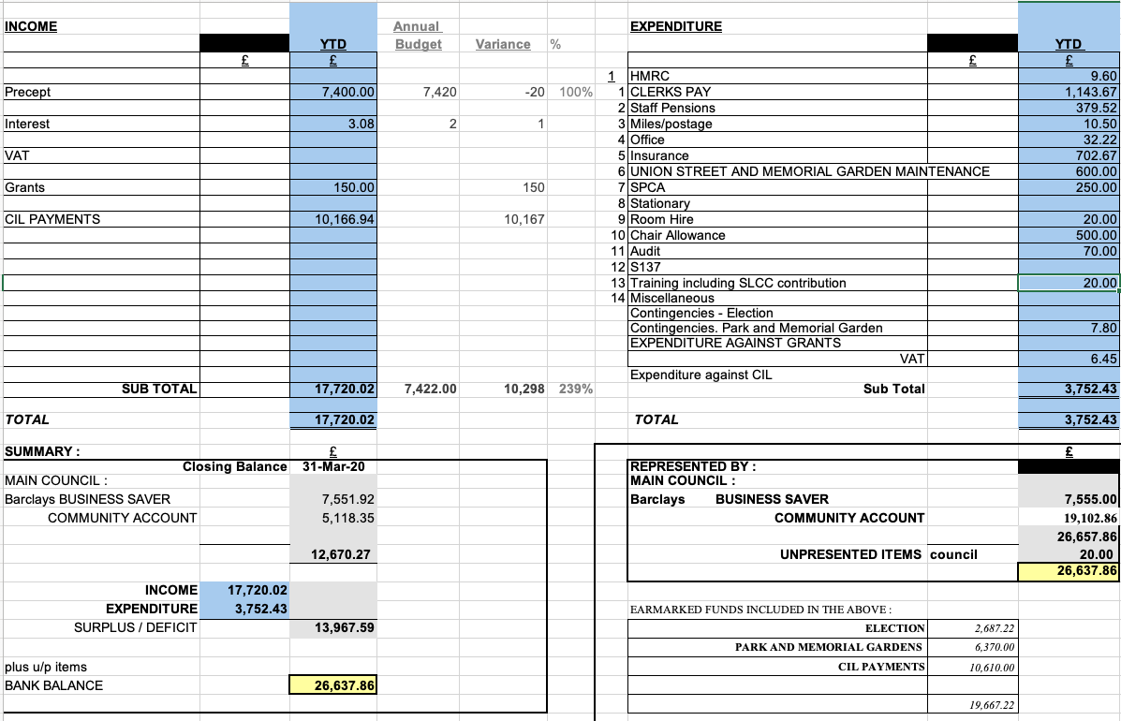

RESOLVED: To approve the accounts.

  - Consideration of Council budget for 2021 – 2022 financial year.

After lengthy discussion, the budget was considered. It was noted that the budget presented by the Clerk included a rise in the budget expenditure of £100.
It was agreed to approve the budget as presented below at £7,500.

RESOLVED: To Approve the budget as presented to the Council.

  - Consideration of 2021 – 2022 precept requirements.

Further to the Budget being accepted as £7,500 it was noted that the £100 increase would, on current 2020 – 2021 figures raise the Band D precept for residents by £0.16p, which represented a 1.3% increase.

RESOLVED: It was proposed, seconded and agreed that a Precept of £7,500 would be requested.
A recorded vote was requested. All members agreed the Precept request would be £7,500 apart from Cllr. Paul Snape who had wished the Precept to remain at £7,400

It was agreed the Council would look at the accounts reserves closely and consider reducing the reserves in the Recreational area earmarked budget. This item would be included on the next agenda.

It was also agreed that although the Parish Council published their budget each year, residents still had very little understanding on the works of the Council. It was noted that the Council would consider ways of promoting what the Council did.

Following a discussion on the contract the Council had with the gardener, it was greed that Cllr. Val Jones will liaise with the gardener prior to next meeting and discuss the way forward. Although it was noted that volunteers carried out a lot of work, the Council was reluctant to depend on voluntary work, but would hopefully work alongside the gardener.

It was also noted that Cllr. Eccleston had planted 500 bulbs in the Memorial Garden on Union Street.

  - Consideration of financial support for Cannock Chase Dementia Alliance Group.

Cllr Val Jones made a presentation and advised the Council on the work of the Dementia Alliance Group.

RESOLVED. It was agreed to make a donation of £150 to the Cannock Chase Dementia Alliance Group.

- Consideration of issues arising to comply with Website Accessibility Standards and possible cost implications of requesting to accept the County Council Parish Website template offer.

Following legislation that came into force in September 2020 the parish Council website has to show that it was working towards accessibility standards (WCAG2). To comply and update the website the Clerk had made enquiries regarding an offer with Staffordshire County Council, of a website accessibility standards template package. Although the project was on hold due to the current pandemic it was agreed to request to on their waiting list for the Silver Package, currently costing £125 per annum and any associated costs for a new website.

RESOLVED: To request to go on Staffordshire County Council waiting list for Silver Website Package which involved an annual fee.

It was noted that Cllr. Matt Freeman agreed to assist with any issues in setting up a new website.

- Highways Issues – matters arising for attention.

  - Consideration of issues regarding the continuing problem of parking on double yellow lines and obstruction of pathways.

Cllr. Snape had advised that there were already lots of double yellow lines on both sides of Bridgtown Primary School, so traffic regulations were already in place. He had requested Clear Streets to visit the area at appropriate times in the school timetable.

Cllr. Bob Eccleston advised that the main problem appeared to be parents dropping off pupils at the start and end of the School day. It was agreed that Cllr. Paul Snape would liaise with Bridgtown Primary School and ask what measures they could implement to educate the parents regarding the parking problems and if any help could be given by the Parish Council.

RESOLVED: Cllr Paul Snape to liaise with Bridgtown Primary School to work on initiatives to ease parking problems outside the school.

  - Consideration of HGV traffic and signage on Lakeside Boulevard

Cllr. Snape agreed to chase up any outstanding signage but it was noted that Mark Keeling at the County Council who dealt with signage, had only just returned from sick leave, but would update the Council at the earliest convenience.

It was noted that a lot of the problems were that the larger HGVs were being directed by Sat Navs down unsuitable streets. It was suggested that to help the drivers, extra signage advising ‘Not Suitable for HGV traffic’ would possibly ease the problem. It was agreed to make enquiries regarding this type of signage and what funding it would need. If possible, the Council could enquire if CIL money could be used for road signage.

No further issues arose, not already on the agenda.

- Items for Information or Future Agendas.

Future Agendas-
Consideration of suitable infrastructure projects for the next five years.
CONFIDENTIAL ITEM Consideration of Councillor Vacancy.
Consideration of suitable infrastructure projects for the next five years.
Consideration of amounts in Recreational Areas, earmarked budgets.
Consideration of Garden Maintenance Contract

Items for Information: Cllr. Val Jones offered to pass on any information regarding and new legislation reports, including Planning. It was also noted that SPCA would also be running a course.

RESOLVED: The above items on the next Council Agenda.

- Date of Next Meeting.

It was agreed that the next Meetings would be 13th January 2021.

Members were thanked for their attendance and the meeting was then closed.

