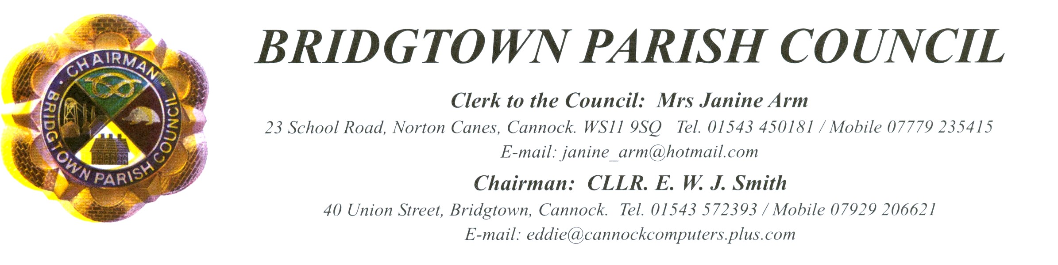
You are hereby summoned to the Annual General Meeting of Bridgtown Parish Council.
To be held on 20th May 2015 commencing 7.35 pm.
At
Bethel Church, Union Street. Bridgtown

A G E N D A

There will be a Public Participation session prior to the meeting commencing

Welcome to the new Council by the current Chairman.

- Election of Chairman.
- Signing of the Declaration of Office.
- Apologies received in writing prior to the meeting.
- Election of Vice Chairman.
- Declaration of interests on Agenda Items and consideration of Dispensations where appropriate.
- To Approve the Minutes of the Meetings held on 4th March 2015.
- Matters Arising from the Minutes.
- Consideration of applications for Casual Vacancy.
- Appointment of Committees, outside representatives and Co-ordinators.
  - Parish Councils Standards Sub Committee Representative.
  - Independent Internal Auditor.
- Chairman’s Report.
- Memorial Gardens and Union Street Play Area and Associated Matters.
- Planning:
  - Applications for Consideration.
  - Applications Approved/Rejected by District Council.
- Correspondence
  - Incoming.
  - Outgoing
- Accounts.
  - Accounts for Consideration.
  - Current Financial situation of the Council
- Consideration of Audit Matters.
  - Consideration of Approval of end of year Accounts and the Annual Audit Statement of Accounts
  - Consideration of Approval of the Annual Governance Statement.
- Items for Information or Future Agendas.
  - For Information

- Date of Next Meeting: - 8th July 2015

CONFIDENTIAL ITEMS: - EXCLUSION OF PRESS AND PUBLIC WHEN APPLICABLE.

9th May 2015
Mrs J Arm - Clerk to the Council

